

**Informatics Institute**

**of Technology**

Machine Learning &

Data Mining

5DATA002W

Coursework Report

Name : Rayaan Rilshad

IIT Student ID: 20211315

UoW ID: w1899330

Tutorial Group: R

# Table of Contents

**Table of Contents 1**

**Partitioning Clustering 2**

1st Subtask 2

a. Pre-Processing 2

b. Determining Number of Cluster Centres using Automated Tools 5

I. NBclust 5

II. Elbow 6

III. Gap Statistics 6

IV. Silhouette 7

Conclusion 7

c. k-Means Clustering 8

d. Silhouette Plot 10

2nd Subtask 11

e. PCA Analysis 11

f. Determining Number of Cluster Centres for the PCA based dataset 13

I. NBclust 13

II. Elbow 13

III. Gap Statistics 14

IV. Silhouette 14

Conclusion 14

g. k-means Clustering for PCA-based Dataset 15

h. Silhouette Plot for PCA-based dataset 16

i. Calinski-Harabasz Index 17

**Energy Forecasting 18**

a. Input Variables for MLP Models in Electricity Load Forecasting 18

1st Subtask (AR Approach) 19

b. Time-Delayed Input/Output (I/O) Matrix 19

c. IO Matrix Normalization 20

d. Training & Testing the MLP-NN Model 21

e. Standard Statistical Indices 24

f. Performance Comparison 25

2nd Subtask (NARX Approach) 26

**Appendix 28**

1. Clustering Code 28

2. PCA Code 28

3. AR Model Code 28

4. NARX Model Code 28

**References 28**

# Partitioning Clustering

## 1st Subtask

### Pre-Processing

Pre-processing is the process of clean and transform raw data into the suitable format for using in analysis. This process is important because, raw data may be incomplete, inconsistent, or contain errors, which can effect the accuracy and the efficiency of of the analysis. Pre-processing includes tasks such as removing missing or NULL values, normalizing data (Scaling) and handling outliers.

In the pre-processing task, the first step is to load the data and remove any unwanted data, such as missing or NULL values. For example, in the "vehicles.xlsx" dataset, the "Sample" and "Class" columns are not important because the "Sample" column contains the row number and the "Class" column contains the vehicle type, which is not required for unsupervised learning.

library(readxl)

*# Read the Excel file*

vehicles <- read_excel("/Users/rayaan/Edu/ML & DS/ML Coursework/PC Part/vehicles.xlsx")

*# Remove the first and last columns*

vehicles <- vehicles[, -c(1, ncol(vehicles))]

*# Remove rows with missing values*

vehicles <- na.omit(vehicles)

#### 

In the dataset, the data points are calculated and measured using different methods. The machine learning module cannot understand this, so it is important to scale the data to the same scale.

vehicles <- scale(vehicles)

In the R code, the scale( ) function was used to scale the dataset, which is using z-score method. This ensures that all data points contribute equally to the analysis and are on the same scale. And after the scaling process, the dataset is looks like below image.

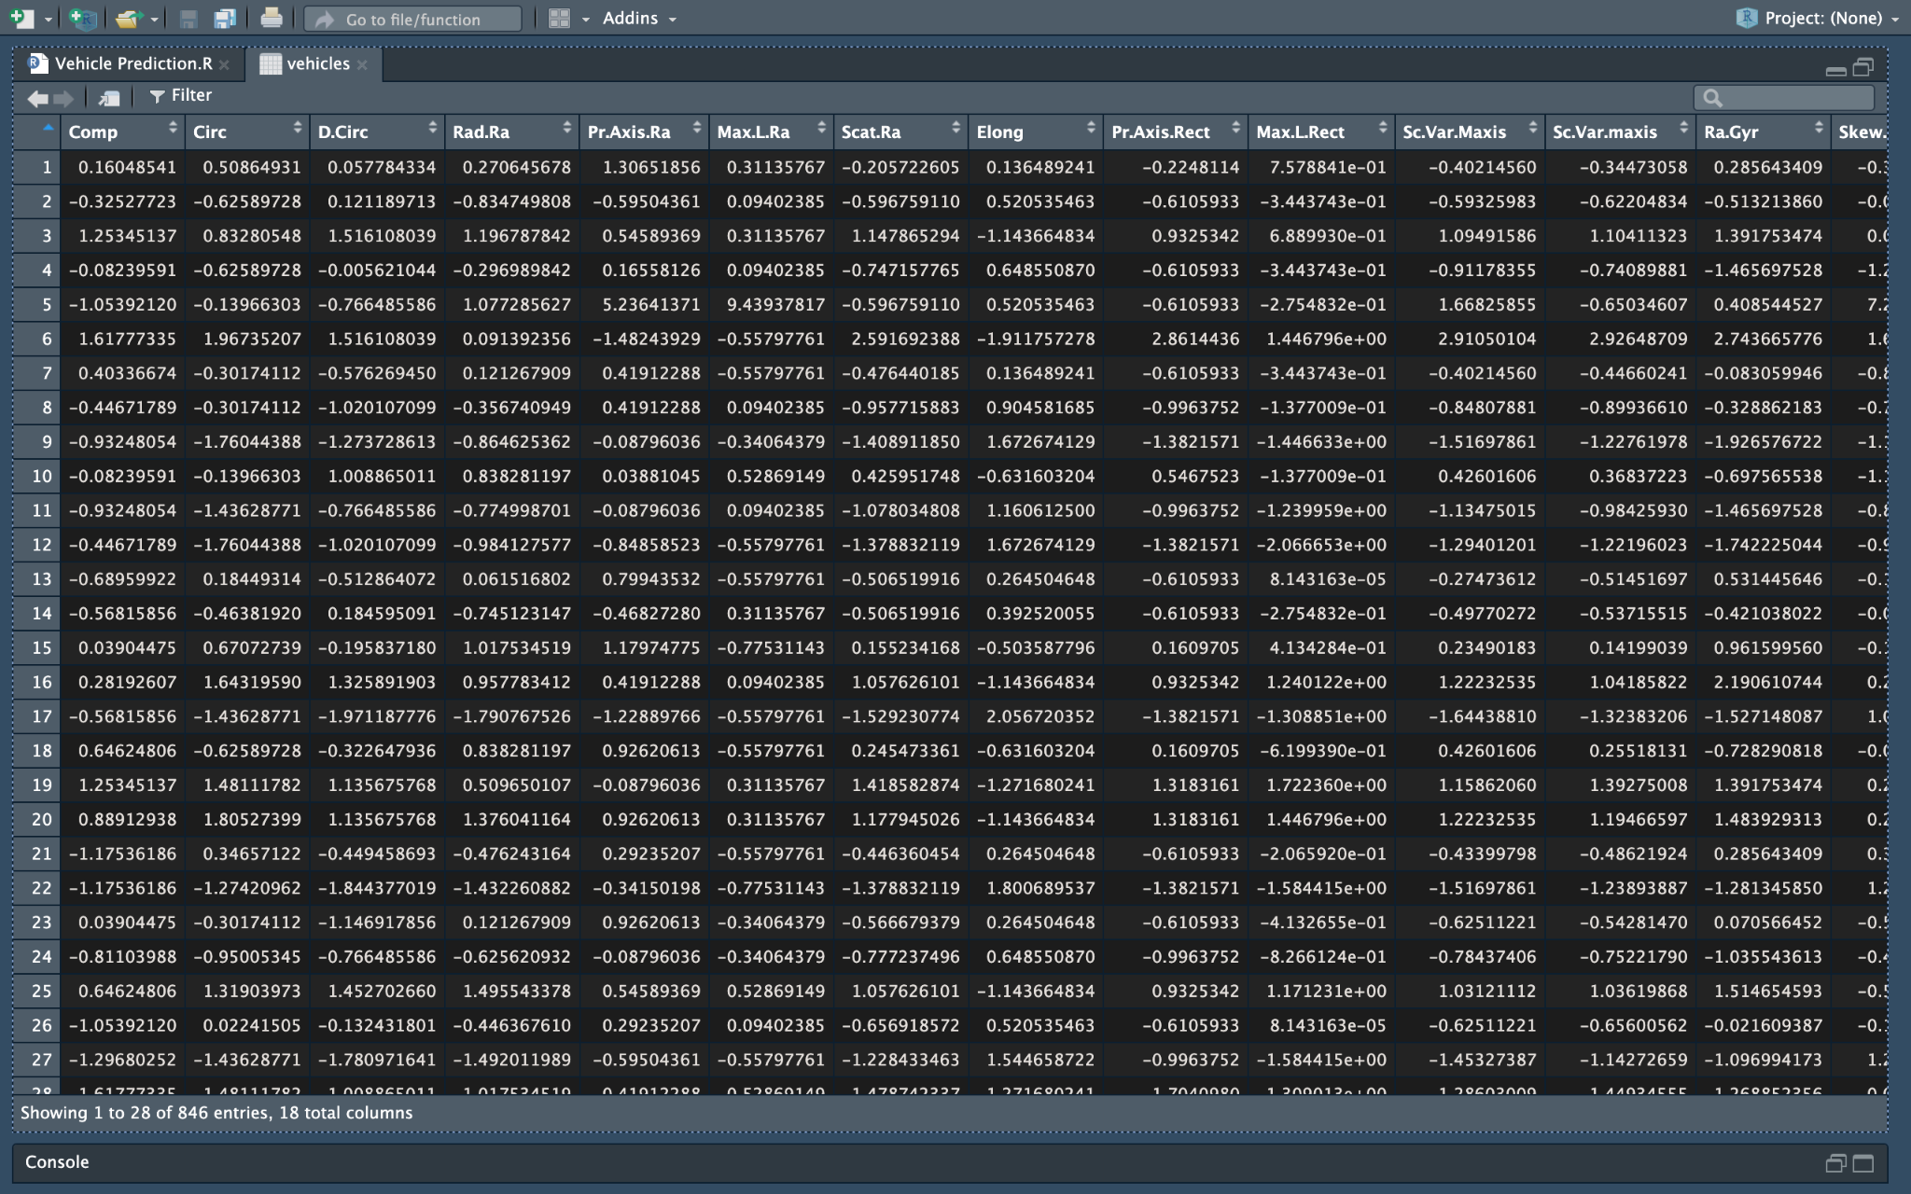

Outliers are data points that are very different from the rest of the data. They can be caused by mistakes in data entry, measurement errors, or just natural variations. Outliers can mess up machine learning models, so it's important to find and remove them before training a model. This is also uses the z-score method to identify outliers. A z-score tells how far a data point is from the average of its data group and If a data point has a z-score that's bigger than a certain number, it's an outlier. In this case, it is considered as 3.

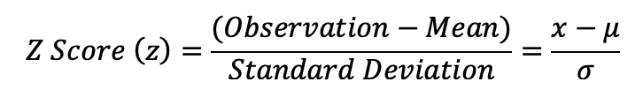

*outliers <- apply(vehicles, 1, function(x) any(x > 3 | x < -3))*

According to the below image, it is detected 22 outliers out of 846 datapoints in the vehicles dataset

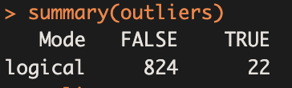

And the boxplot method will help to get a visual representation of the outliers.

boxplot(vehicles)

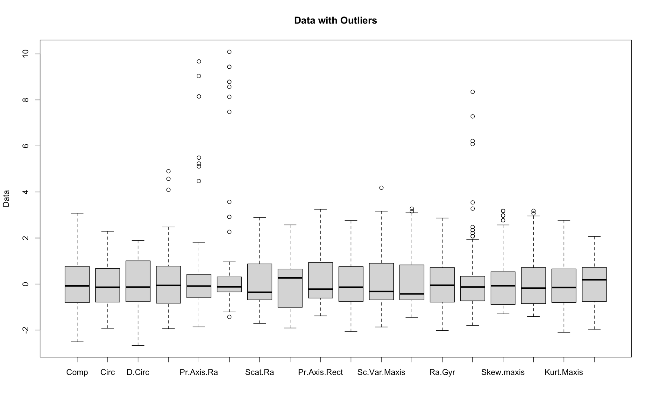

According to the above image and the summary of the outliers, there are several outliers in the dataset. So it is necessary to remove them from the dataset to get an accurate analysis.

*vehicles <- subset(vehicles, !outliers)*

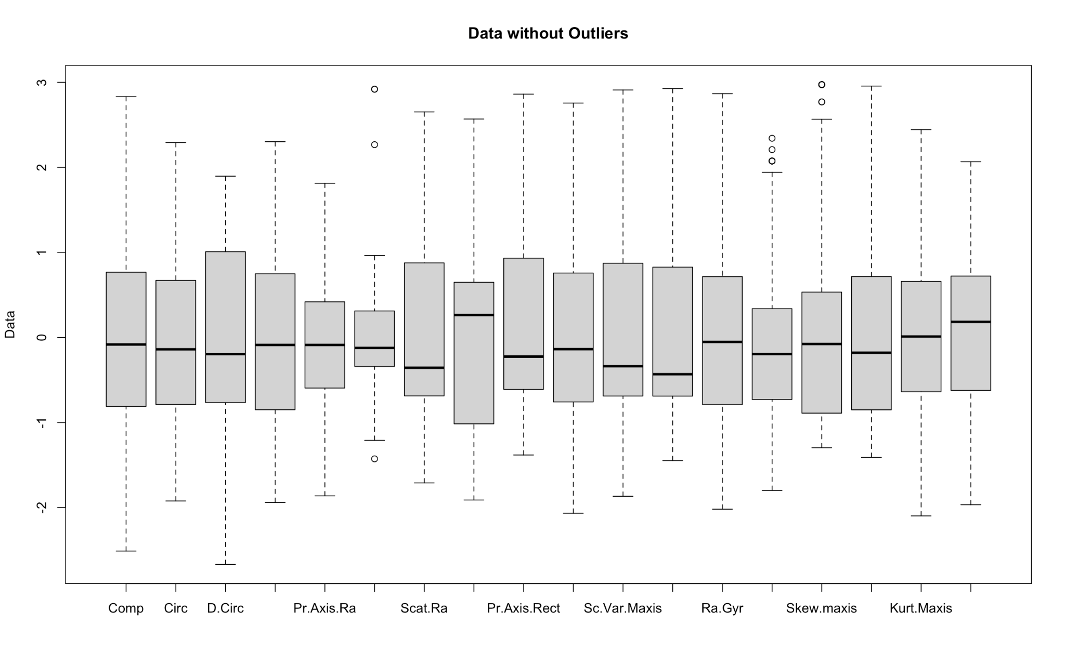

All the outliers, which are bigger than 3 and less than 3 are removed from the dataset.

### Determining Number of Cluster Centres using Automated Tools

A cluster is a group of similar data points in a dataset. As required, to determine the number of cluster centers in the vehicles dataset using automated tools, NBclust, Elbow, Gap statistics, and silhouette methods are used in this project.

#### NBclust

The NBclust method is used as the first method to determine the best number of clusters using automated tools. To do this, it is required to use the NbClust package and pass the relevant inputs to it. In this case, the “vehicles” dataset is used, and the Euclidean distance metric is used to measure the distance between data points. The clusters are then calculated using the k-means method.

library(NbClust)

NBclust <- NbClust(vehicles, *distance* = "euclidean", *min.nc*=2, *max.nc* =6, *method* = "kmeans")

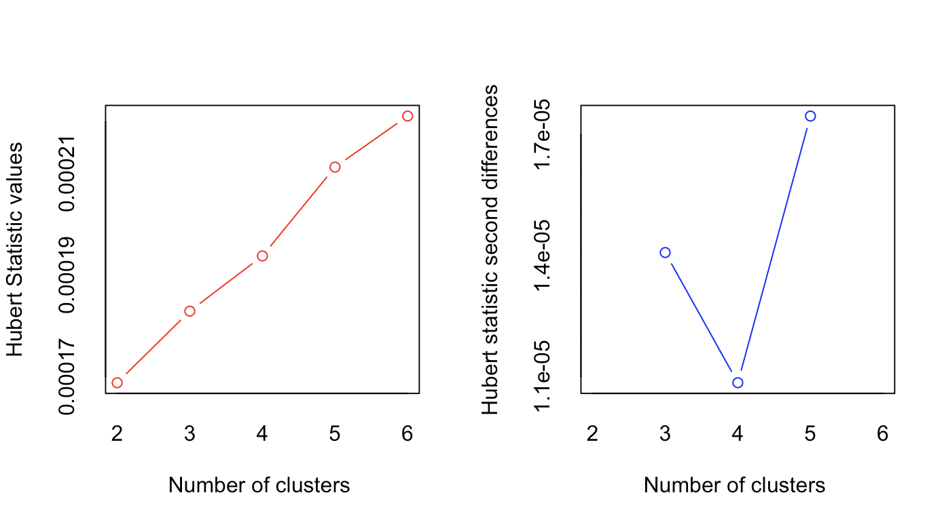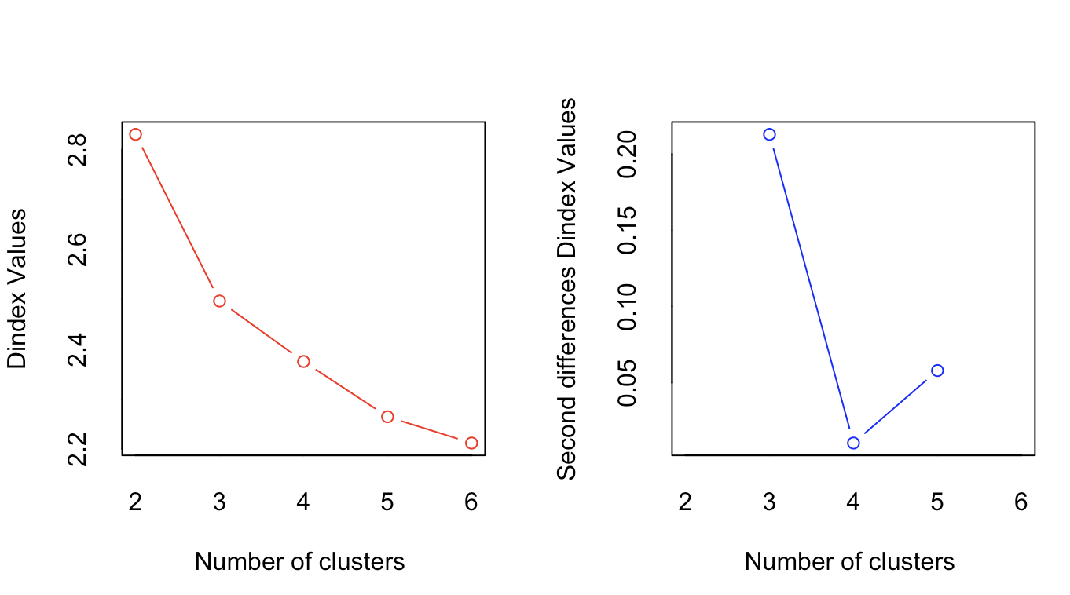

As in the above graphs (Hubert index and the D index) and also in the below figure, the NBClust method clearly predicts a conclusion that the best number of clusters is 3 according to the majority rule.

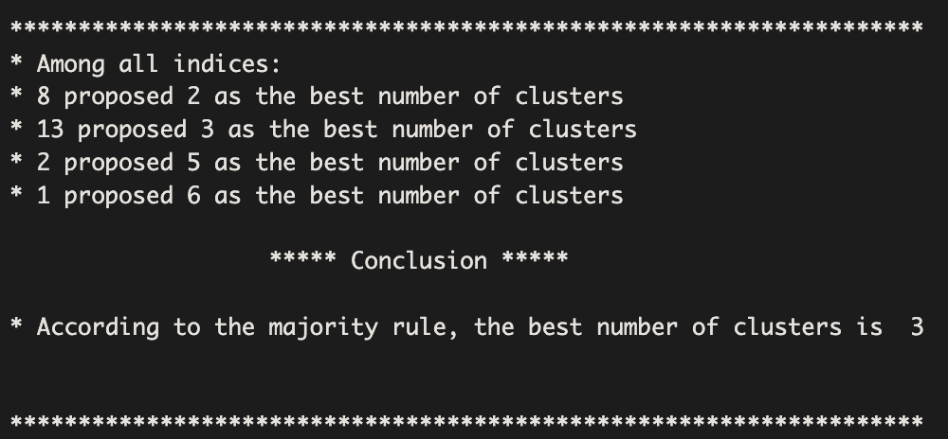

#### 

#### Elbow

The next method is Elbow. It is a simple way to find the best number of clusters in a dataset. It works by plotting the within-cluster sum of squares (WSS) against the number of clusters. The WSS is a measure of how spread out the data is within each cluster.

fviz_nbclust(vehicles, kmeans, *method* = "wss")

Basically the elbow method is finding a point on the curve, where the WSS is starts to decrease more slowly. That's called the "elbow" and the number of clusters at the elbow is the best number of clusters because it means the data is most evenly distributed among the clusters.

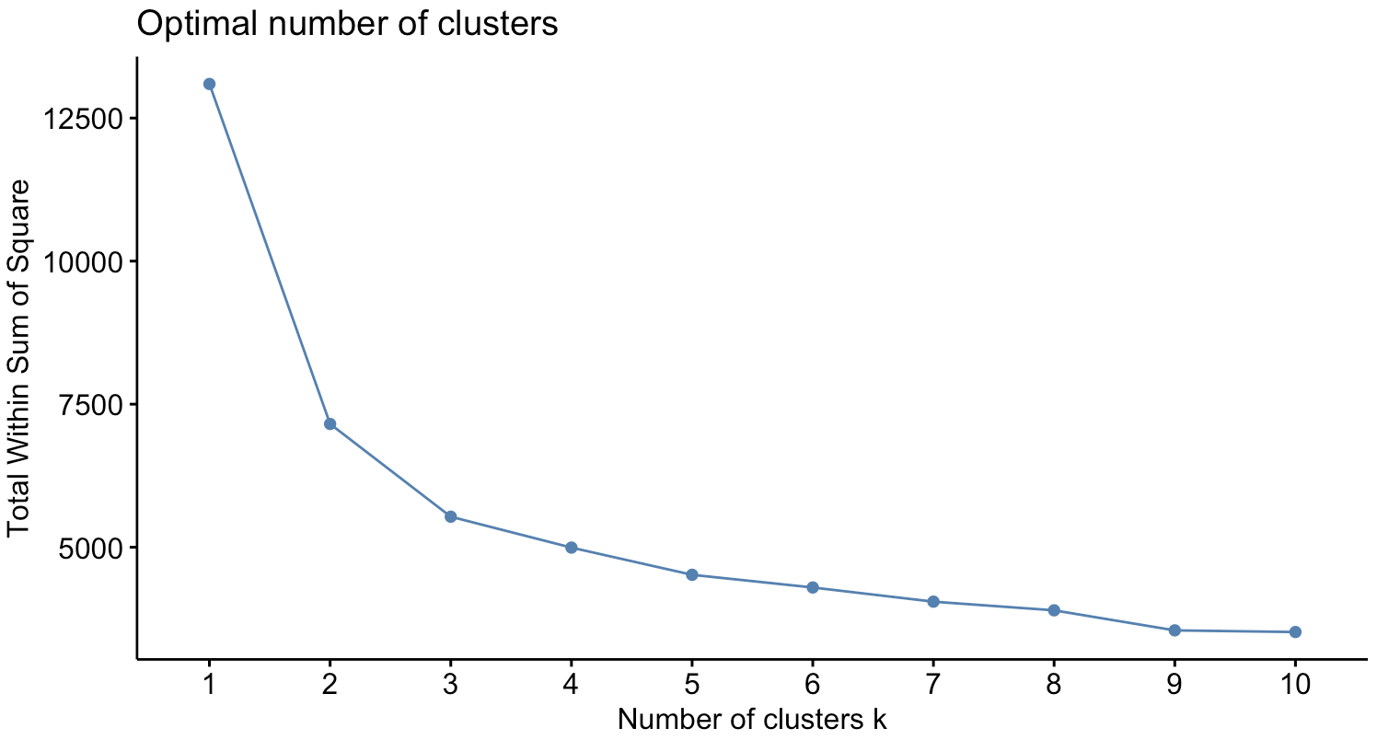

According to the elbow method that the 3 clusters seems to be the best number of clusters to use in the vehicle dataset.

#### Gap Statistics

Gap statistics is all about comparing the WSS of the data to the WSS of randomly generated data with the same number of clusters.

fviz_nbclust(vehicles, kmeans, *method* = "gap_stat")

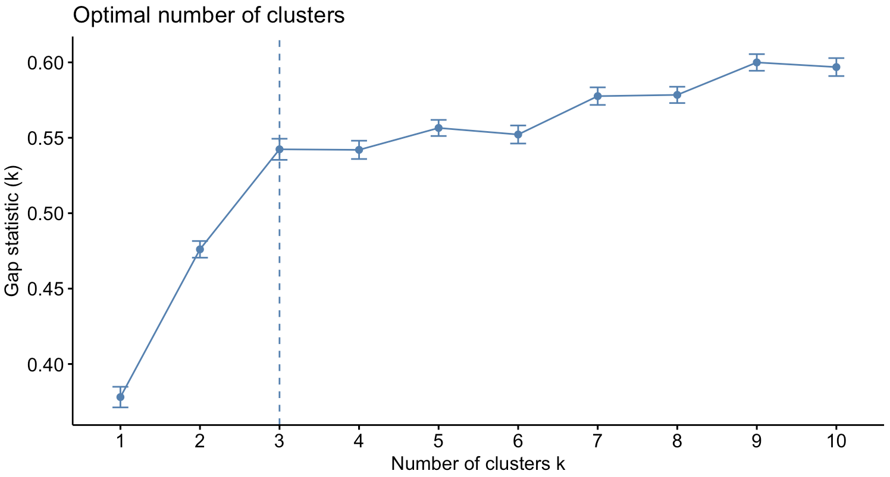

In the gap statistic method, the best number of clusters is the one which has the biggest gap between the two WSS values. And in this case, the gap statistic predicts that the best number of clusters is 3.

#### Silhouette

Silhouette is another automated tool to calculate the number of clusters and it calculates the average silhouette width for each cluster, which tells how similar each data point is to its own cluster compared to other clusters.

fviz_nbclust(vehicles, kmeans, *method* = "silhouette")

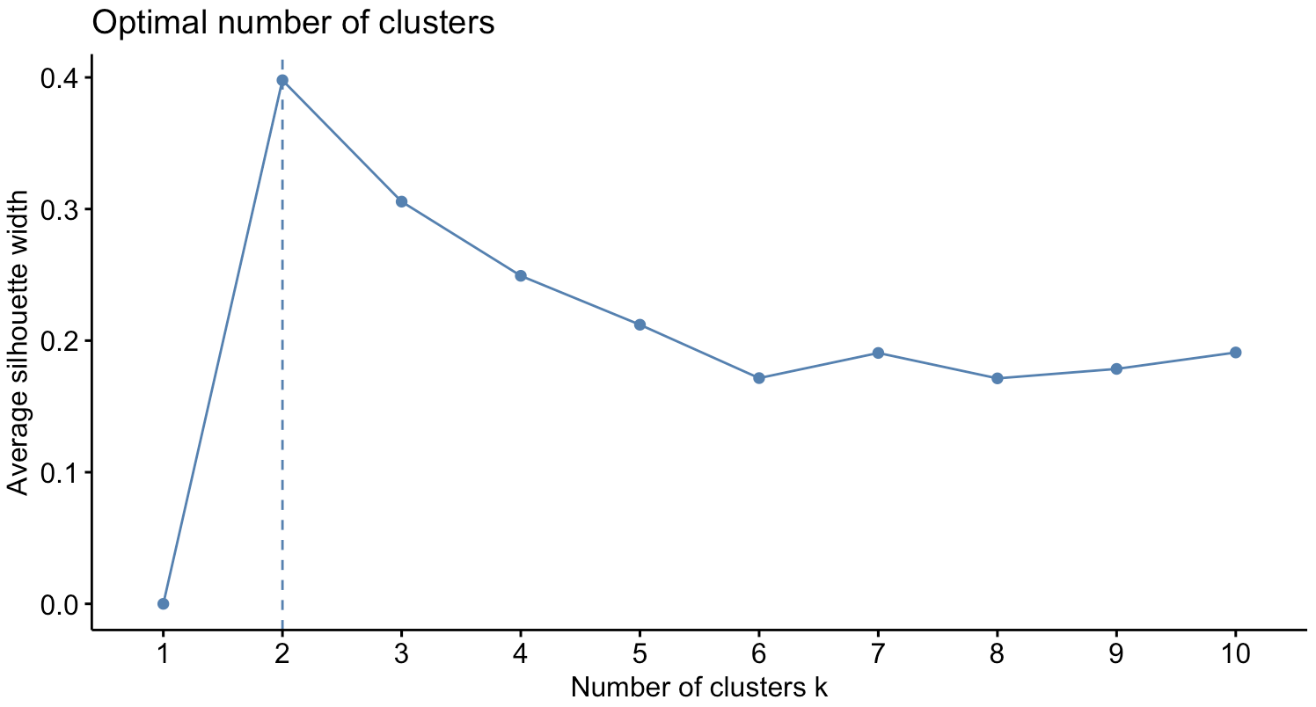

In this case, the best number of clusters is the one that has the highest average silhouette width within all other clusters. And based on the silhouette method, the best number of clusters for this dataset is 2.

#### Conclusion

| Method | NBclust | Elbow | Gap Statistic | Silhouette |
| --- | --- | --- | --- | --- |
| Suggested  Clusters | 3 | 3 | 3 | 2 |

Based on the results of the four automated tools, the optimal number of clusters seems to be 3 because of the majority methods are suggesting it. The NBclust algorithm, the elbow method and the gap statistics method all suggest that 3 clusters while only silhouette method is suggesting 2. So, as a conclusion k=3 is the best fit for the data.

### 

### k-Means Clustering

Based on the results of the four automated tools, the best number of clusters in this dataset is 3. And

Basically, K-means is starts by randomly assigning each data point to a cluster. Then it calculates the mean of each cluster and moves each data point to the cluster with the closest mean. This keeps happening over and over until the clusters don't change anymore.

k <- 3

km <- kmeans(vehicles, *centers* = k)

As an output of the above code, here are the k-means clustering centers for each variable.

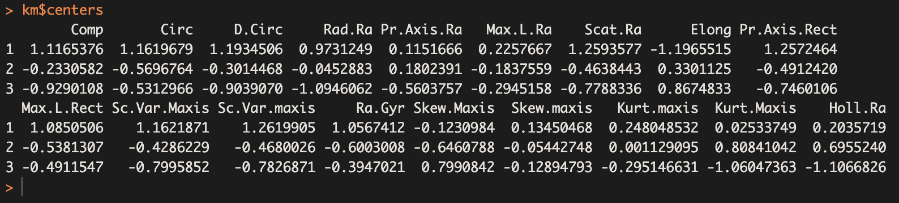

And also, according to the k-means clustering algorithm, the below image shows which data point is assigned to which cluster with 3 clusters.

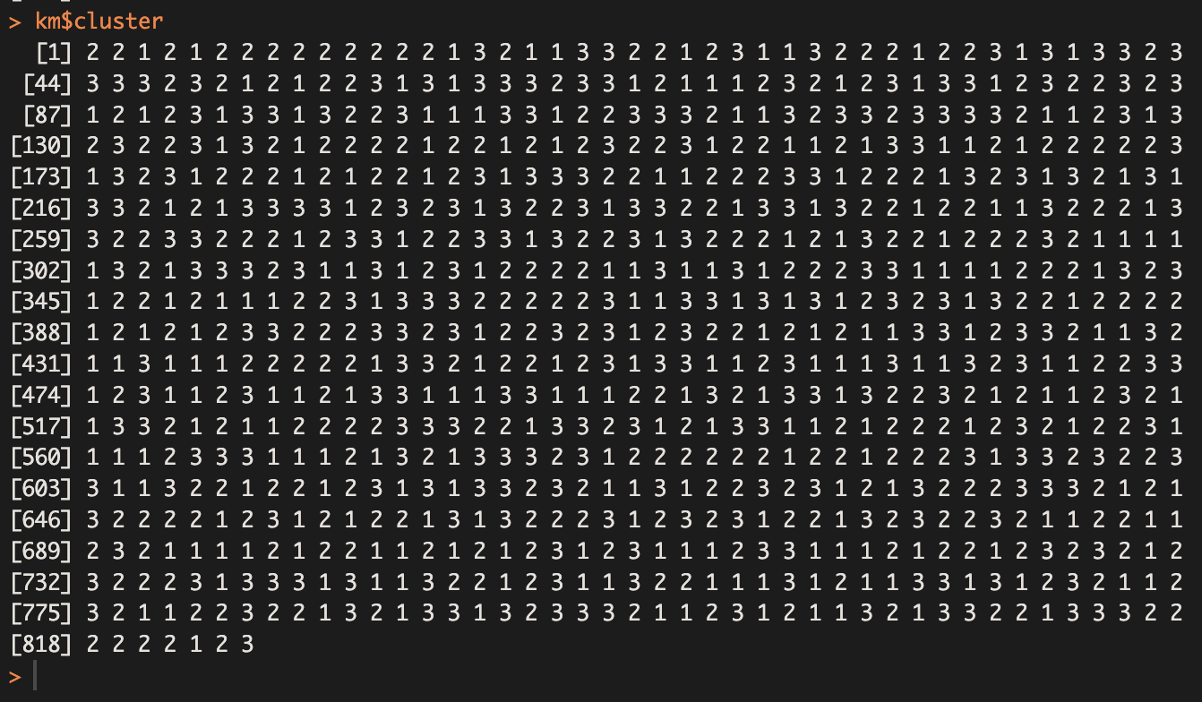

Finally, as a summary of the K-means clustering, the following image visually represents the three clusters, along with their data points.

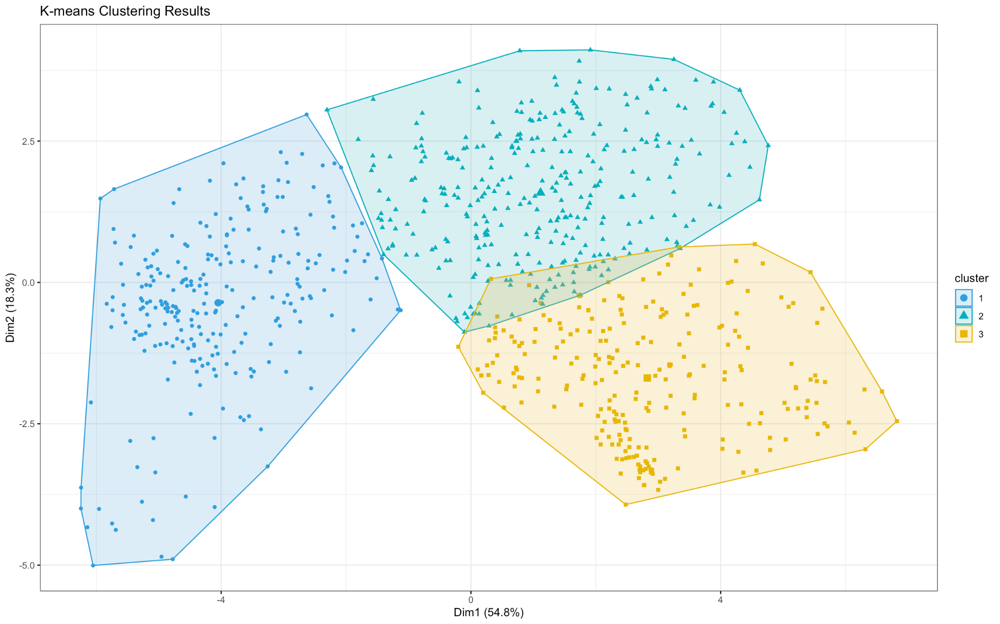

In clustering analysis, the within-cluster sum of squares (WSS), between-cluster sum of squares (BSS), and total sum of squares (TSS) can be used to evaluate the quality of clustering solution.

wss <- sum(km$withinss)

bss <- sum(km$betweenss)

tss <- wss + bss

cat("Ratio of BSS over TSS:", bss / tss)

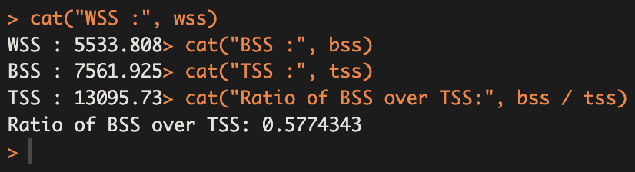

The ratio of BSS over TSS is 0.577, which is close to 0.5, indicating that the model is well-fit.

### Silhouette Plot

The silhouette plot is a useful tool for evaluating the quality of a clustering solution for how close each point in one cluster is to its neighboring cluster. A high average silhouette width indicates that the clustering solution is good, as most of the observations are well-separated from other observations in their own cluster.

*sil_width <- silhouette(km$cluster, dist(vehicles))*

*plot(sil_width, main = "Silhouette Plot for K-means Clustering")*

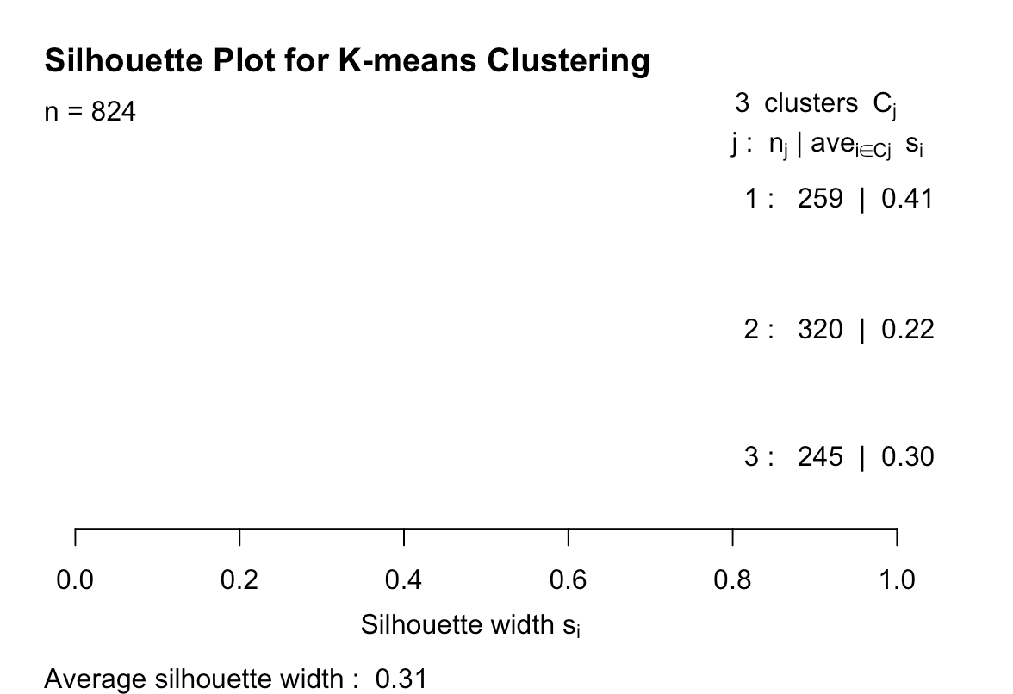

The average silhouette width for the clustering solution is 0.31 and this indicates that the clustering solution is relatively good, as most of the observations are well-separated from other observations in their own cluster.

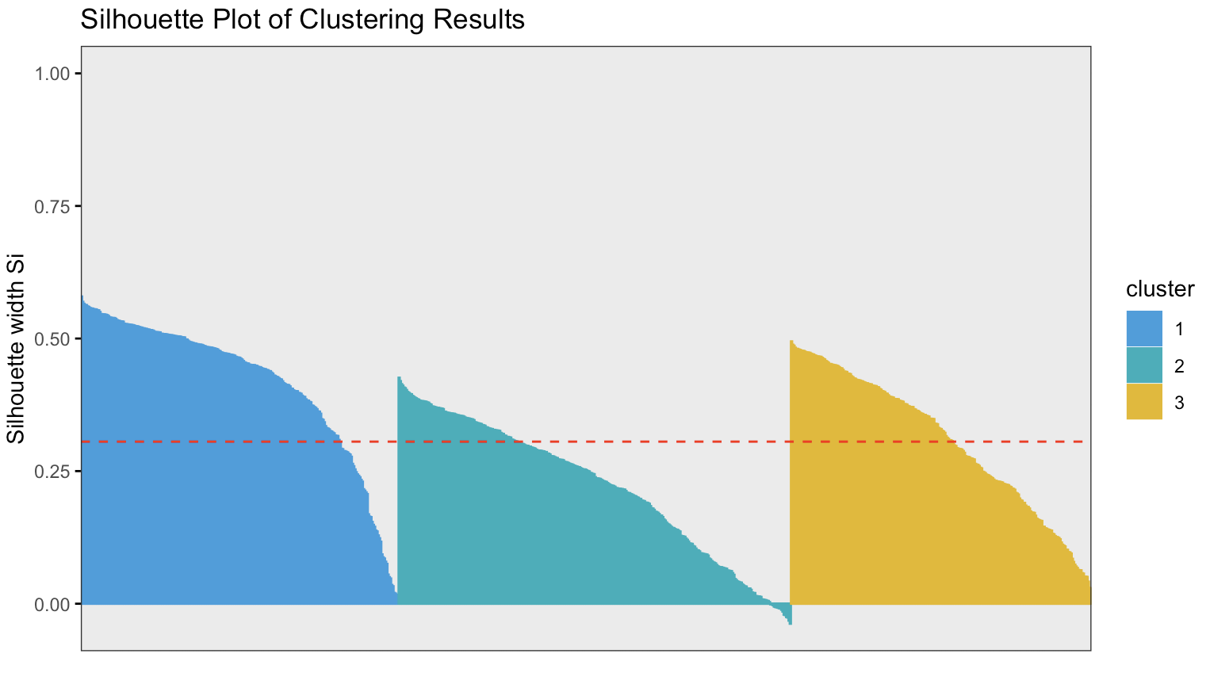

This plot shows that the three clusters are well-defined. The observations in each cluster are close to each other, and also they are well-separated from the observations in other clusters. This suggests that the clustering solution is relatively good.

## 2nd Subtask

### PCA Analysis

In the dataset, all the data sections are not required to do the analysis. Reducing the dimensionality of the dataset and considering as much of the original information as possible is the process of Principal Component Analysis (PCA).

In this project, PCA is performed on the pre-processed "vehicles" dataset using the prcomp( ) function.

pca <- prcomp(vehicles)

The eigenvalues which represents the variance explained by each principal component and the eigenvectors which represent the direction of the PC in the original variable space are extracted from the PCA object using the sdev and rotation attributes, respectively.

eigenvalues <- pca$sdev^2

eigenvectors <- pca$rotation

The cumulative proportion of variance explained is a measurenment of how much of the total variation in the data is accounted for by each PC in a PCA.

cum_prop_var <- cumsum(eigenvalues / sum(eigenvalues))

Choosing the correct number of PCs is an important step in PCA. The first step in choosing PCs is to determine how much variance we want to explain. In this case it is, cumulative score > 92%.

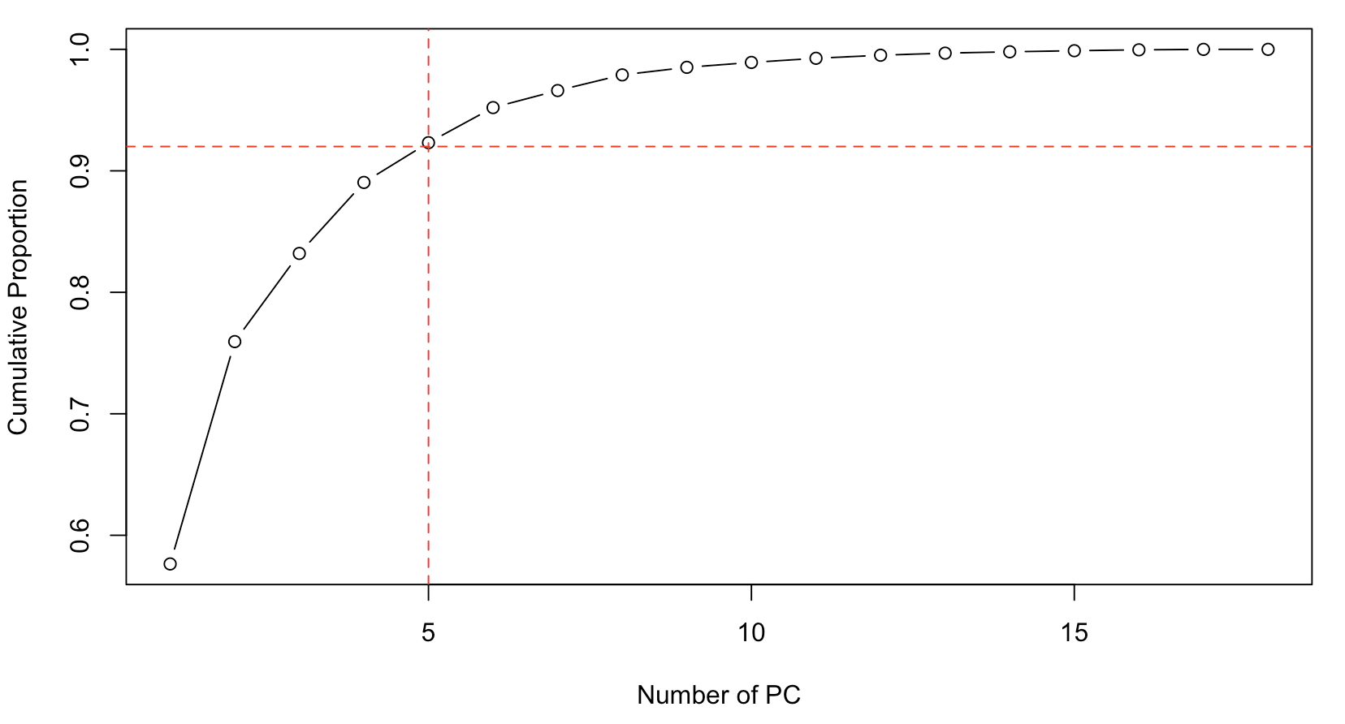

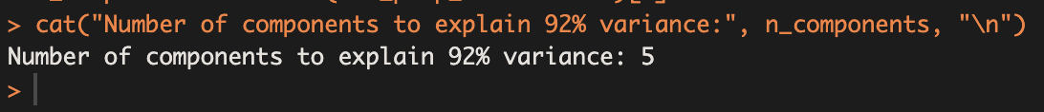

According to the above images, the number of components to explain 92% variance is 5. So, considering that it is required to a new dataset with the chosen PCs.

vehicles_pca <- predict(pca, *newdata* = vehicles)[, 1:n_components]

The newly created table looks like below figure.

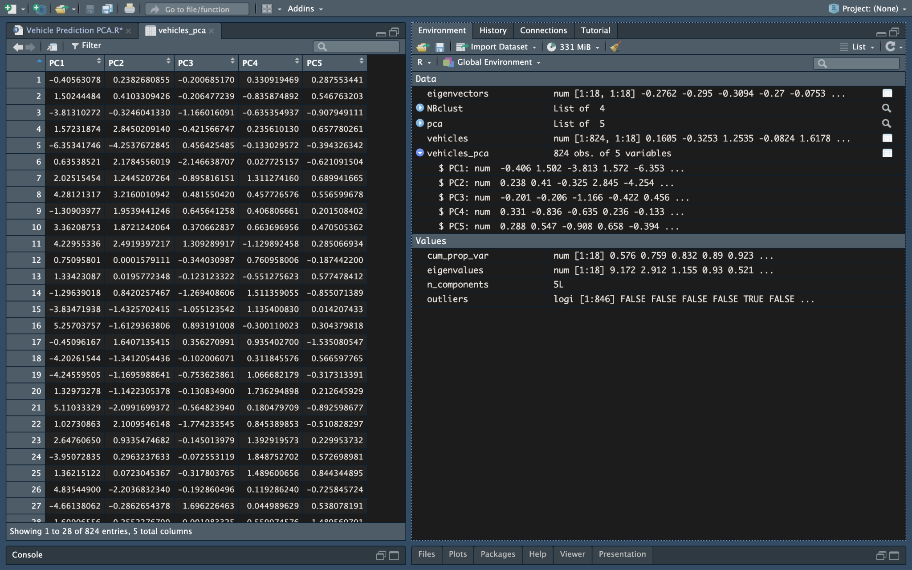

These 5 data column will be the dataset using in PCA analysis.

### 

### Determining Number of Cluster Centres for the PCA based dataset

As discussed in the 1st sub task, NBclust, Elbow, Gap statistics, and silhouette methods can be used in to find the most suitable number of clusters for the dataset.

#### NBclust

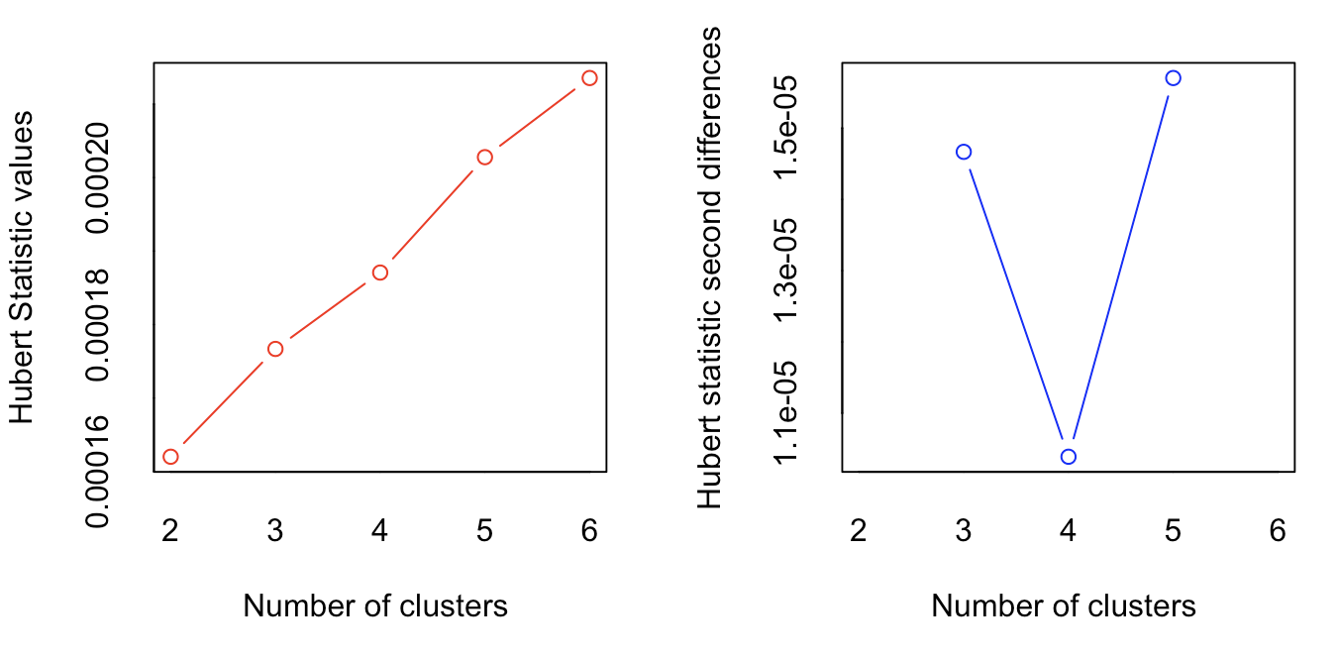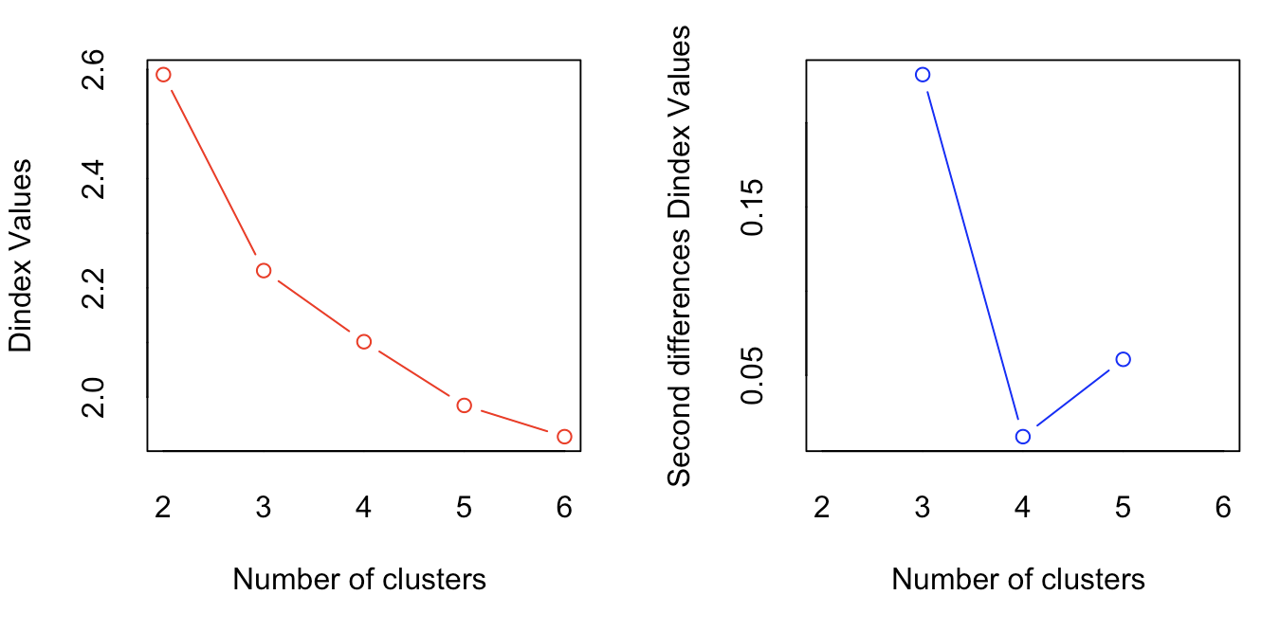

As in the above graphs (Hubert index and the D index) and also in the below figure, the NBClust method clearly predicts a conclusion that the best number of clusters is 3 according to the majority rule.

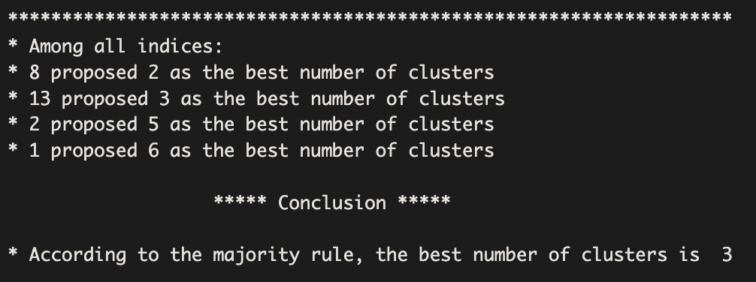

#### Elbow

According to the plot below, the elbow of the curve is at 3 clusters. So, Elbow method is suggesting the 3 cluster as better option.

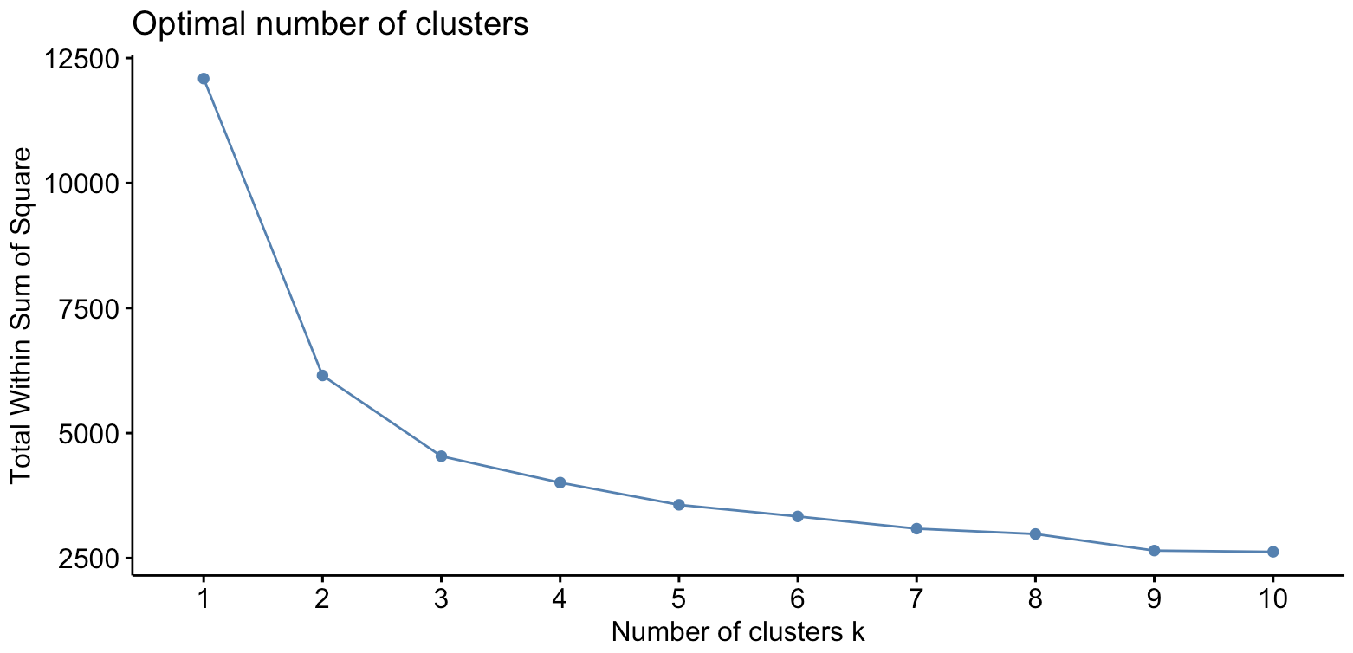

#### Gap Statistics

According to the result of the gap statistic method, it is recommended to use 3 as the number of clusters.

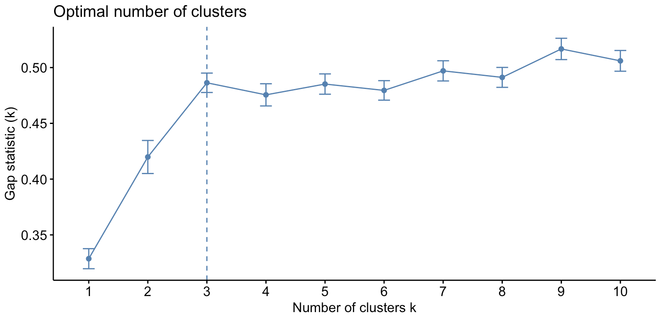

#### Silhouette

The previous 3 automated method are suggested 3, but Silhoutte method is suggesting the number 2 as clusters for the PCA.

#### 

#### Conclusion

| Method | NBclust | Elbow | Gap Statistic | Silhouette |
| --- | --- | --- | --- | --- |
| Suggested  Clusters | 3 | 3 | 3 | 2 |

Based on the results of the four automated tools, the majority is suggesting the optimal number of clusters to be 3. So as a conclusion, the k=3.

### k-means Clustering for PCA-based Dataset

According to the conclution of the automated tools, k=3 will be the most suitable number of clusters.

k_pca <- 3

km_pca <- kmeans(vehicles_pca, *centers* = k_pca)

As an output of the above code, here are the k-means clustering centers for each variable and the cluster data points

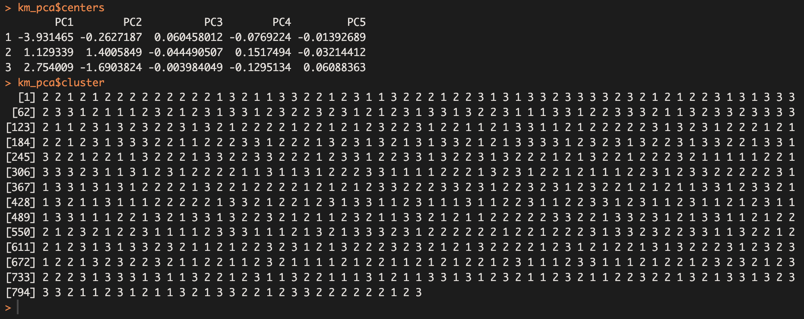

As a summary of the K-means clustering, the below image visually represents the three clusters, along with their variables.

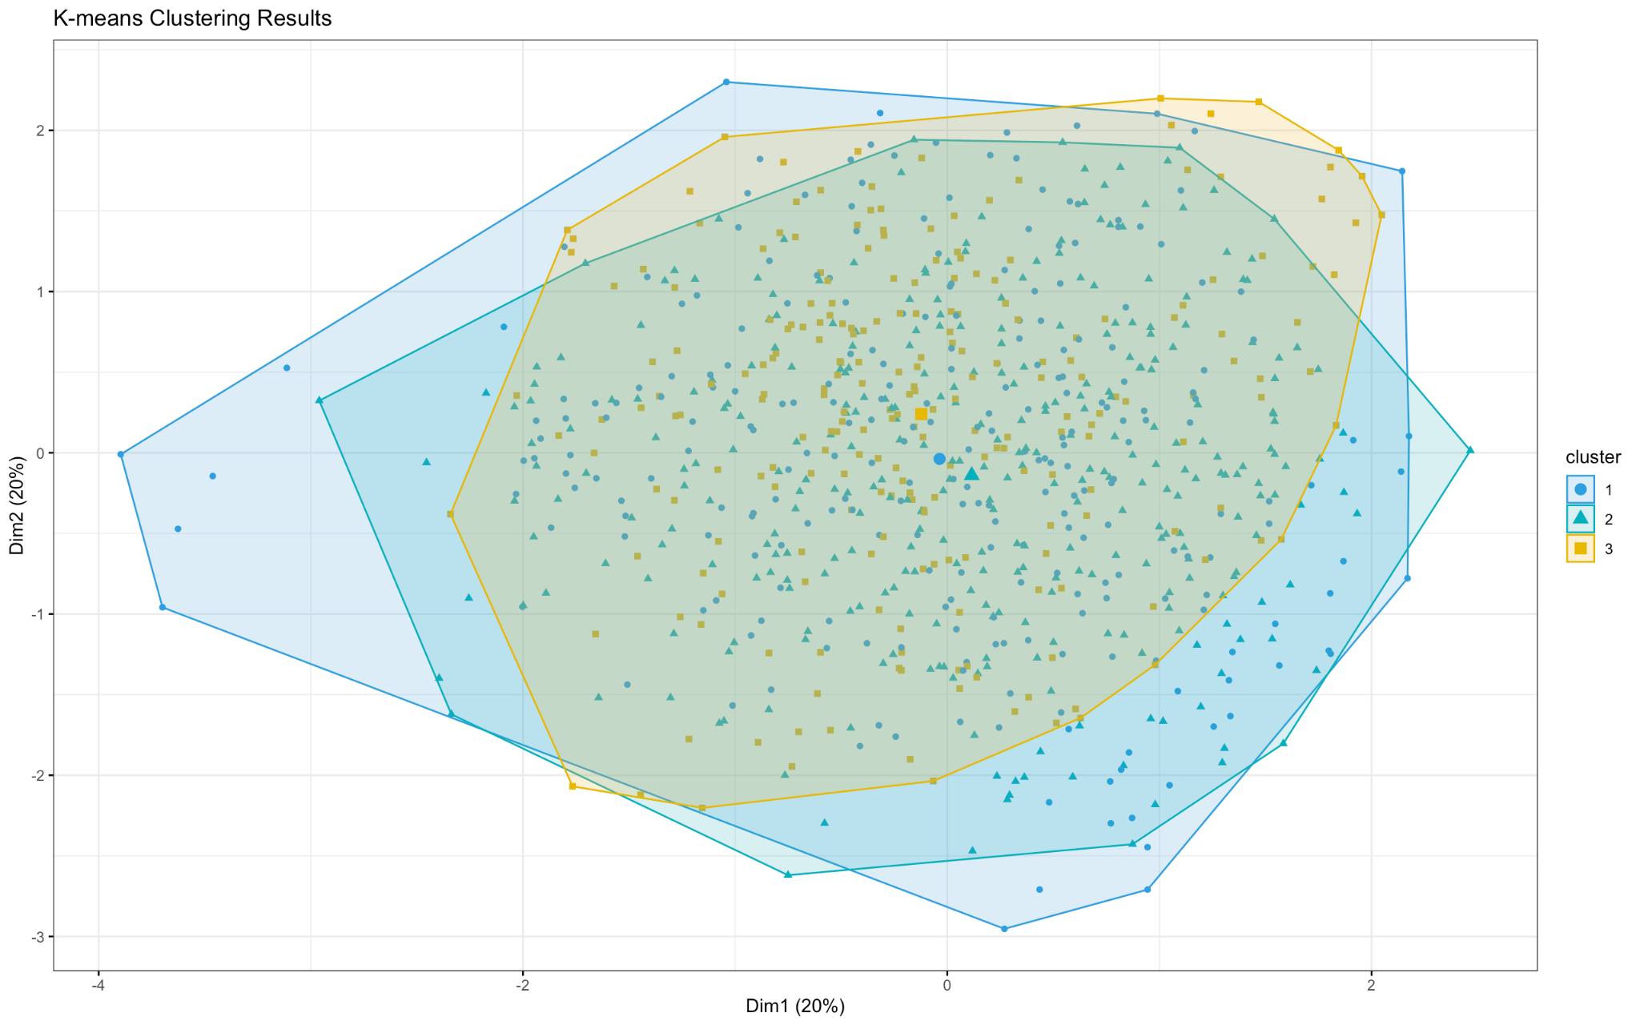

Ratio of BSS over TSS is used to evaluate the quality of clustering solution.

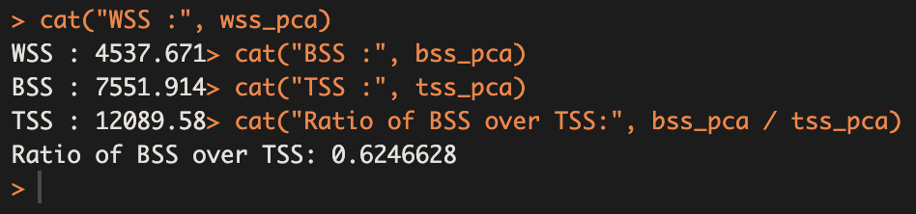

In the PCA-based dataset, the BSS over TSS ratio is 0.62 and for the original dataset it got 0.577. So compared to the original dataset, the PCA-based clustering is provides a better accuracy.

### Silhouette Plot for PCA-based dataset

To evaluate how close each point in one cluster is to its neighboring cluster, the Silhouette method can be used.

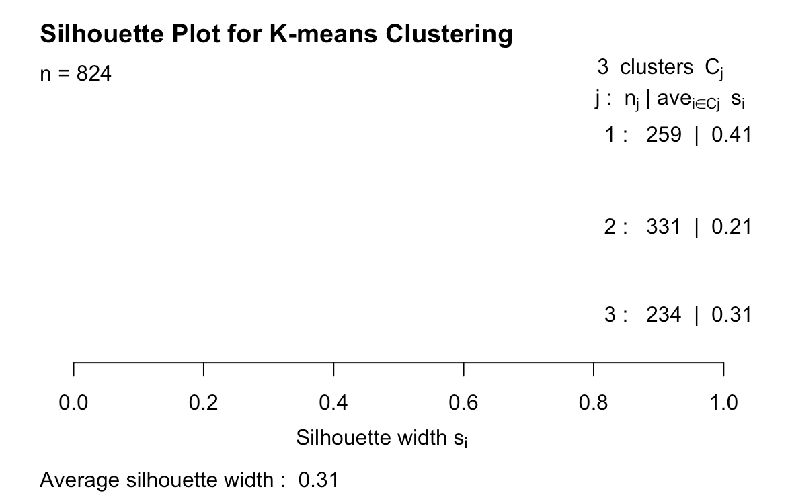

The average silhouette width for the k-means clustering solution is 0.31 as like as in the normal k-means clustering part.

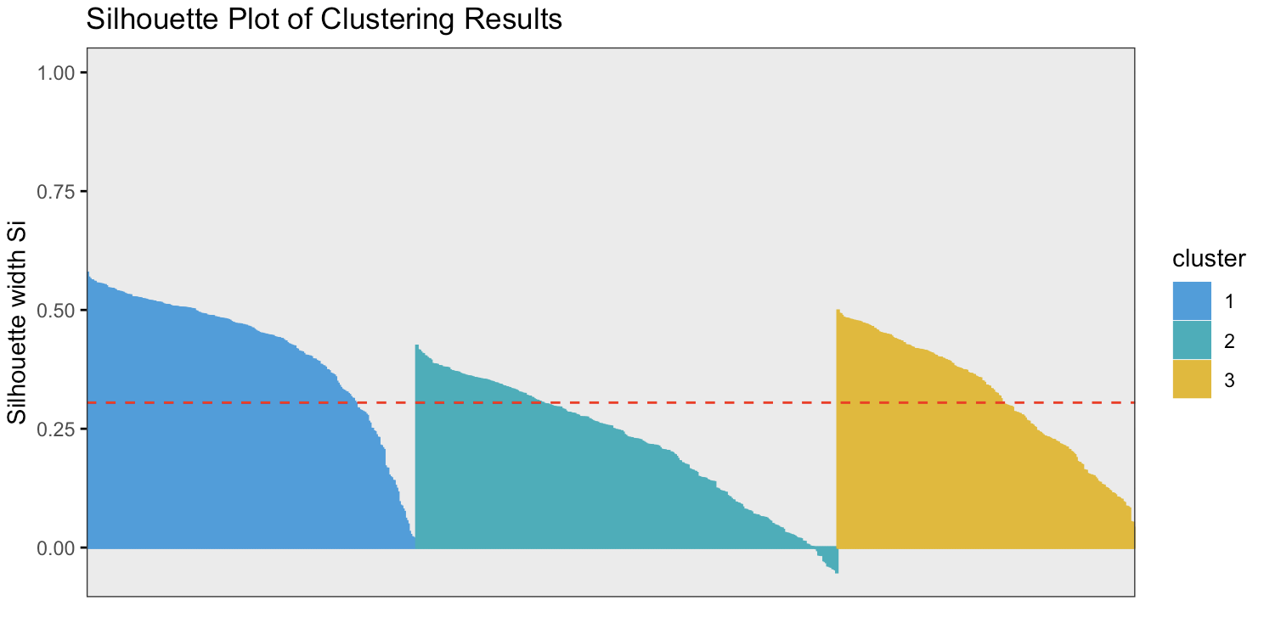

### Calinski-Harabasz Index

The Calinski-Harabasz Index (CH Index) is a method of evaluate the quality of clustering result. This is a measure of separation between clusters and it can be used to compare different clustering solutions. CH Index measures the ratio of between-cluster variance to within-cluster variance.

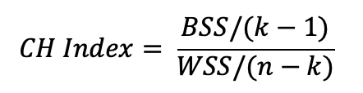

For this purpose, calinhara ( ) function in fvp library is used.

ch_index <- calinhara(vehicles_pca, km_pca$cluster)

A higher value of the CH Index indicates that the clusters are more well-separated.

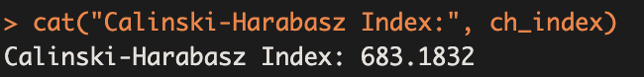

According to this the CH index is 683.18 and it is relatively higher value. So as a conclusion, that the clusters are very well-separated.

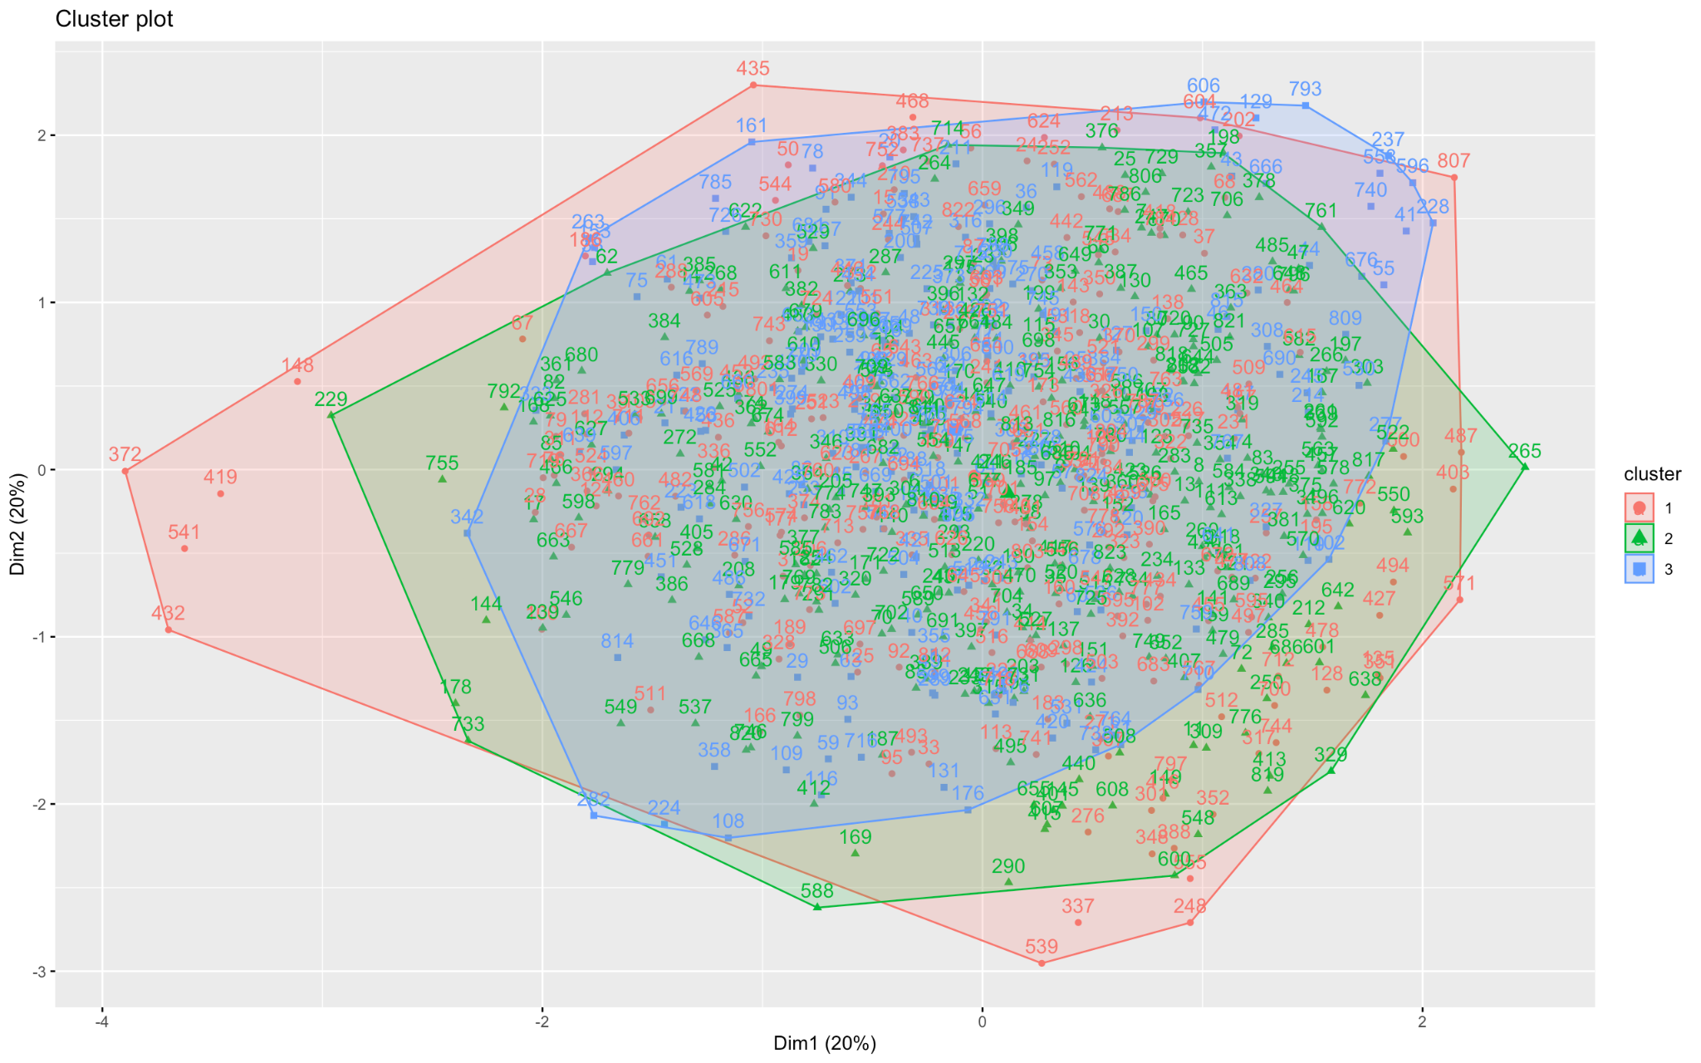

# Energy Forecasting

### Input Variables for MLP Models in Electricity Load Forecasting

In electricity load forecasting, the input variables used in MLP models typically include:

* Lagged variables: This method uses past values of energy usage (previous hour, two hours ago, three hours ago, etc.) as inputs to the neural network to predict future usage. (Zhu et al., 2019)
* Weather variables: Temperature, humidity, and wind speed can have an impact on energy usage. Therefore, they are also used as inputs to the neural network. (Zhu et al., 2019)
* Day and time variables: Energy usage changes throughout the day and week. For example, it is typically higher on weekdays than on weekends, and it is higher during the day than at night. These factors can also be used as inputs to the neural network for energy forecasting. (Zhu et al., 2019)
* Other variables: Economic indicators, population, and events in the area can also be used as inputs to the neural network. (Zhu et al., 2019)

These variables are used to capture the patterns and trends in electricity consumption. There are some commonly used schemas that use these variables to predict future usage. Some of them are:

* Autoregressive (AR) approach: This approach uses past values of energy usage as inputs to predict the future value. (Hyndman, 2018)
* Moving average (MA) approach: The MA approach involves using past forecast errors as inputs to the forecasting model. (Hyndman, 2018)
* Exponential smoothing (ES) approach: This approach uses a weighted average of past values of energy consumption to make predictions. (Hyndman, 2018)
* Artificial neural networks (ANN) approach: ANNs are used to understand complex relationships between variables and are trained on historical data to make accurate predictions. (Hyndman, 2018)

## 

## 1st Subtask (AR Approach)

### Time-Delayed Input/Output (I/O) Matrix

As discussed previously, the AR approach uses past values of the target variable as input to the neural network. In this task, the target variable at 20:00 hours is used. As mentioned in the objectives, the electricity consumption forecast also depends on the load value one week before. Therefore, it is beneficial to obtain the past 7 days of "time-delayed" electricity loads at 20:00 hours.

*t_1* = lag(energyUsage_20, 1)

*t_2* = lag(energyUsage_20, 2)

*t_3* = lag(energyUsage_20, 3)

*t_4* = lag(energyUsage_20, 4)

*t_5* = lag(energyUsage_20, 5)

*t_6* = lag(energyUsage_20, 6)

*t_7* = lag(energyUsage_20, 7)

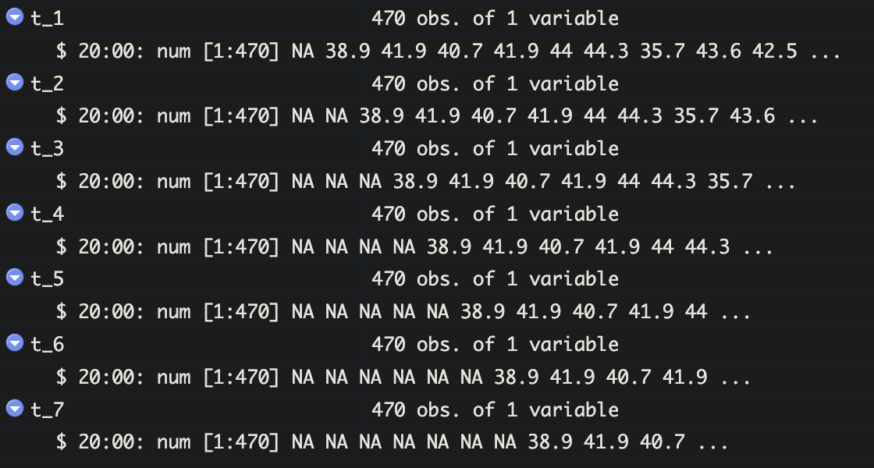

To create an input-output (IO) matrix, it is required to add input and output data. The input data is the time-delayed electricity load, and the output data is the expected result, which is the electricity usage at 20:00 hours. Several matrices were created to identify the best-performing matrix to get the most accurate result.

*input_data_1 <- data.frame(t_3, t_2, t_1)*

*input_data_2 <- data.frame(t_4, t_3, t_2, t_1)*

*input_data_3 <- data.frame(t_7, t_4, t_3, t_2, t_1)*

*input_data_4 <- data.frame(t_7, t_6, t_5, t_4, t_3, t_2, t_1)*

*input_data = input_data_4 #Select the input data*

output_data <- energyUsage_20

*# Normalize the data and create the IO Matrix*

io_matrix <- cbind(scale(input_data), scale(output_data))

As shown in the above code, various inputs are created. During the testing period, the required input data will be assigned to the input_data variable and passed into the IO Matrix. The IO Matrix will then be created for the required input and output.

For example, if it is required to test the t_7, t_4, t_3, t_2, and t_1 time delayed data, then input_data_3 should be assigned to the input_data variable.

*input_data* = input_data_3

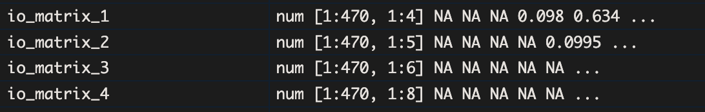

Basically, in the original code, the matrix name will be “i0_matrix”, but for the visualization all the matrix in a single image, those 4 matrices with different outputs are renamed with different names. The above image represen the io matrix data and below figure shows the summary of those matrices. And these data are already scaled because, the scaling and the create matrix is happens in single code line.

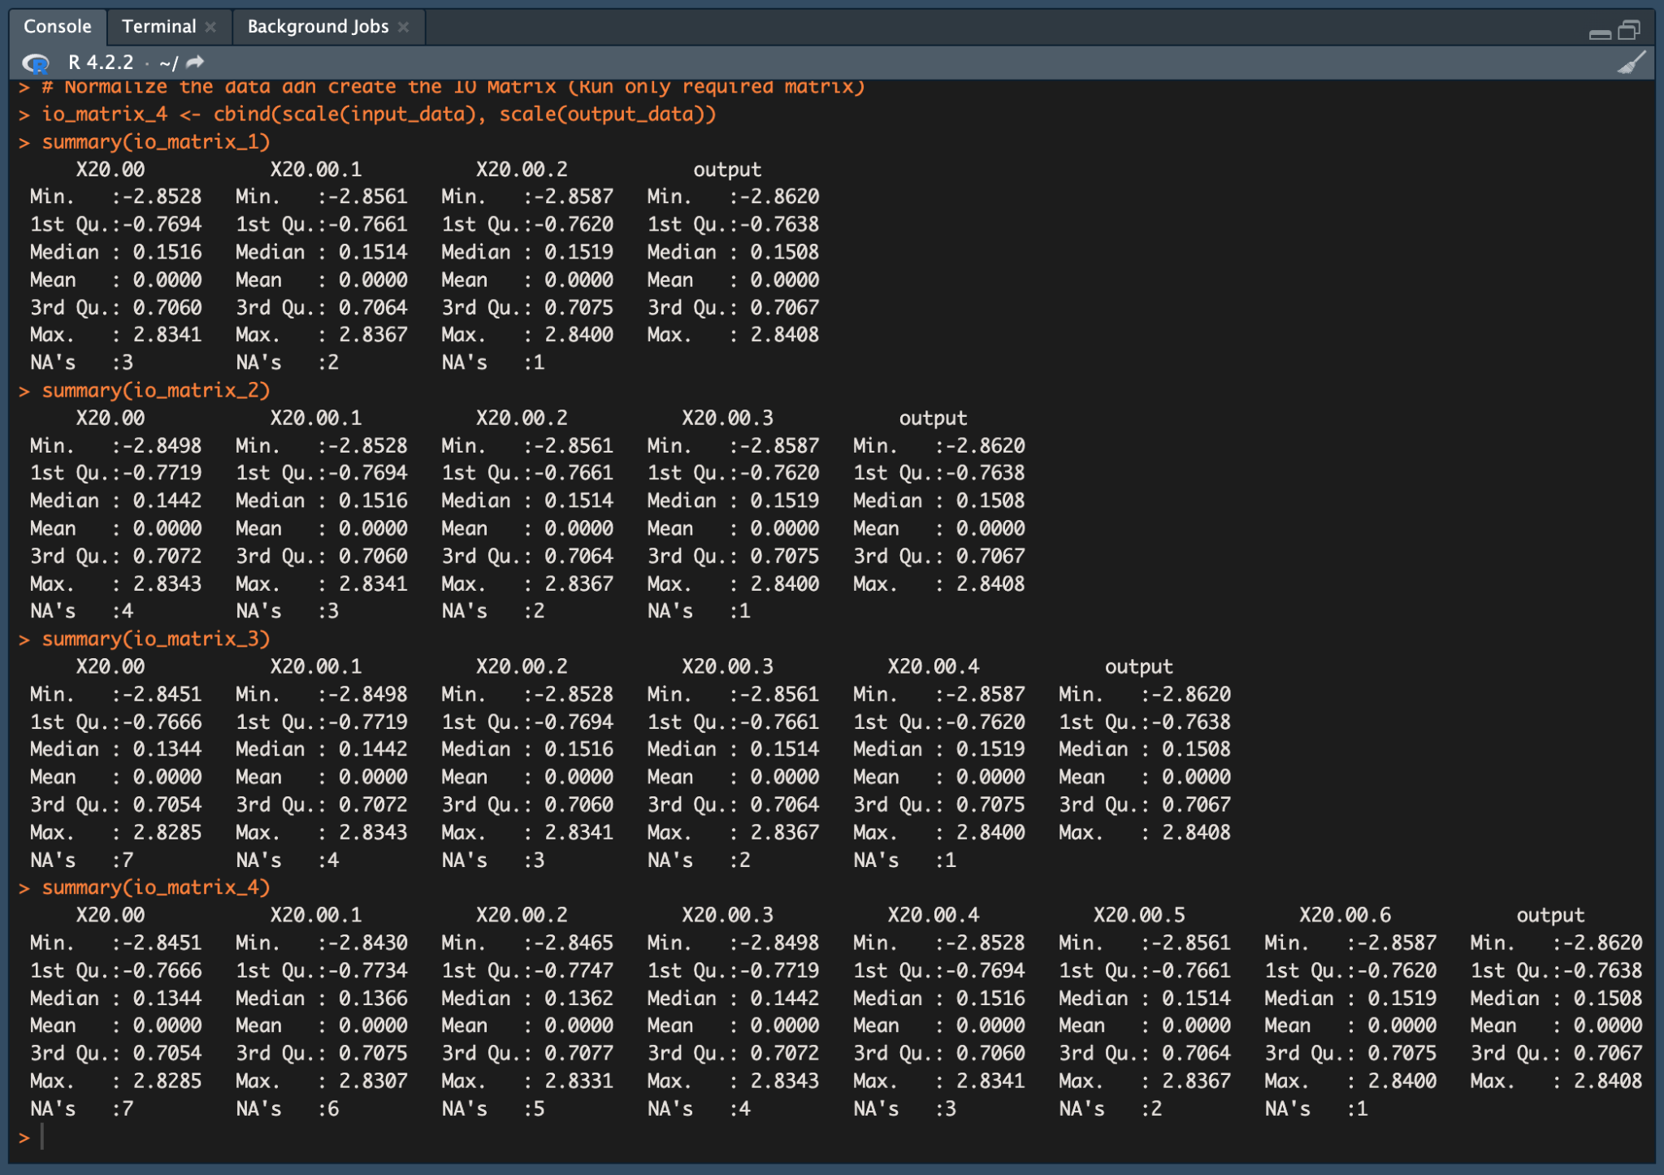

### 

### IO Matrix Normalization

In a dataset, data points can be measured or calculated using different methods and measurements. Machine learning models cannot understand these differences, and MLPs are sensitive to the scale of their inputs. This can affect the efficiency and accuracy of the machine learning model. Therefore, it is important to normalize all data points to the same scale. This is done through normalization.

Basically, normalization is the process of converting data to the same scale (-1 to 1). This can be done in a number of ways, but using the scale( ) function in R is a common method, which uses the z-score to normalize the data.

io_matrix <- cbind(scale(input_data), scale(output_data))

In this code, the input and output data are normalized before being bound into the io_matrix. Once the data is normalized, it can be used to train the MLP model. And below image shows the normalized matrix data.

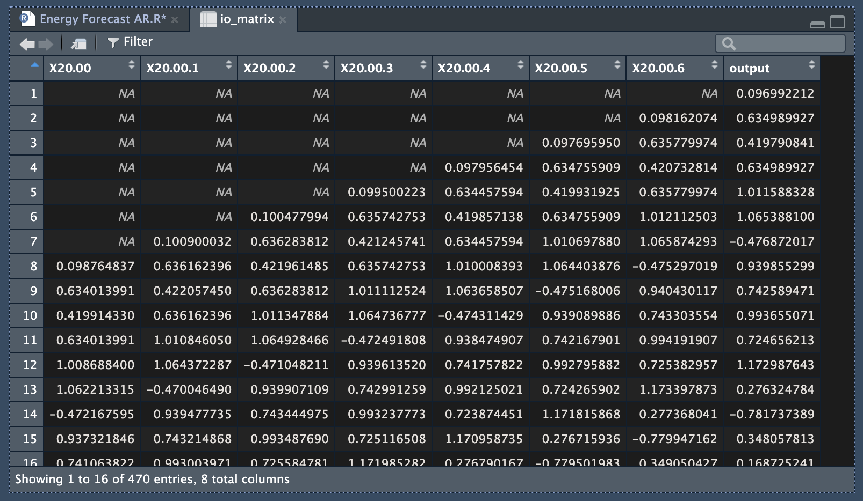

After the clearing the NA values, dataset looks like this.

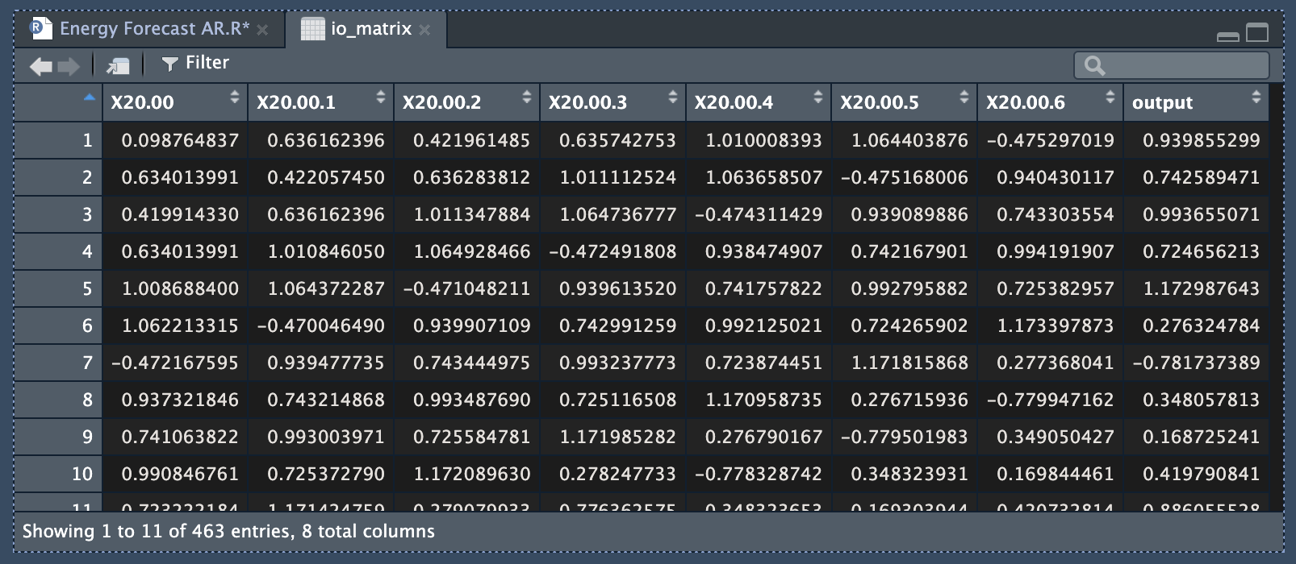

### Training & Testing the MLP-NN Model

Training and the testing is the next stop after the data normalization and creating matrix. As required first 380 matrices are added into the training dataset and rest of the matrices are added to the testing dataset.

train_data <- io_matrix[1:380, ]

test_data <- io_matrix[381:nrow(io_matrix), ]



Training the MLP model is the main part of this process. As previously mentioned, there are different IO matrices. Therefore, it is necessary to train a different type of MLP model for each of them. This will allow to get a conclusions based on the results and find the most accurate and efficient model.

mlp <- neuralnet(output ~ .,

*data* = train_data, *hidden* = c(5),

*act.fct* = "logistic",

*linear.output* = FALSE)

Above code shows the main mlp model and it will train the neural network to predict the output variable based on the input variables in the train_data data set, using a given activation function in the hidden layers and a non-linear activation function in the output layer.

The code below shows the different types of models, which used different hidden layers (one and two layers) and activation functions (logistic, tanh, and relu) to train and test the NN.

mlp_2 <- neuralnet(output ~ ., *data* = train_data, *hidden* = 20, *act.fct* = "logistic", *linear.output* = FALSE)

mlp_3 <- neuralnet(output ~ ., *data* = train_data, *hidden* = c(10,5), *act.fct* = "logistic", *linear.output* = FALSE)

mlp_4 <- neuralnet(output ~ ., *data* = train_data, *hidden* = c(15,20), *act.fct* = "logistic", *linear.output* = FALSE)

mlp_5 <- neuralnet(output ~ ., *data* = train_data, *hidden* = 5, *act.fct* = "tanh", *linear.output* = FALSE)

mlp_6 <- neuralnet(output ~ ., *data* = train_data, *hidden* = 15, *act.fct* = "tanh", *linear.output* = FALSE)

mlp_7 <- neuralnet(output ~ ., *data* = train_data, *hidden* = c(5,10), *act.fct* = "tanh", *linear.output* = FALSE)

mlp_8 <- neuralnet(output ~ ., *data* = train_data, *hidden* = c(10,20), *act.fct* = "tanh", *linear.output* = FALSE)

mlp_9 <- neuralnet(output ~ ., *data* = train_data, *hidden* = 8, *act.fct* = "relu", *linear.output* = FALSE)

mlp_10 <- neuralnet(output ~ ., *data* = train_data, *hidden* = 17, *act.fct* = "relu", *linear.output* = FALSE)

mlp_11 <- neuralnet(output ~ ., *data* = train_data, *hidden* = c(8,17), *act.fct* = "relu", *linear.output* = FALSE)

mlp_12 <- neuralnet(output ~ ., *data* = train_data, *hidden* = c(10,15), *act.fct* = "relu", *linear.output* = FALSE)

The below image shows the the MLP neural network plot for the fist mlp, which is using the 3 input data *input_data_1 (t_3, t_2, t_1)*  in the io matrix. And also the 5 hidden layers and logistic activation function. The plot clearly represents the input, hidden layers and the output with the scaled datapoints.

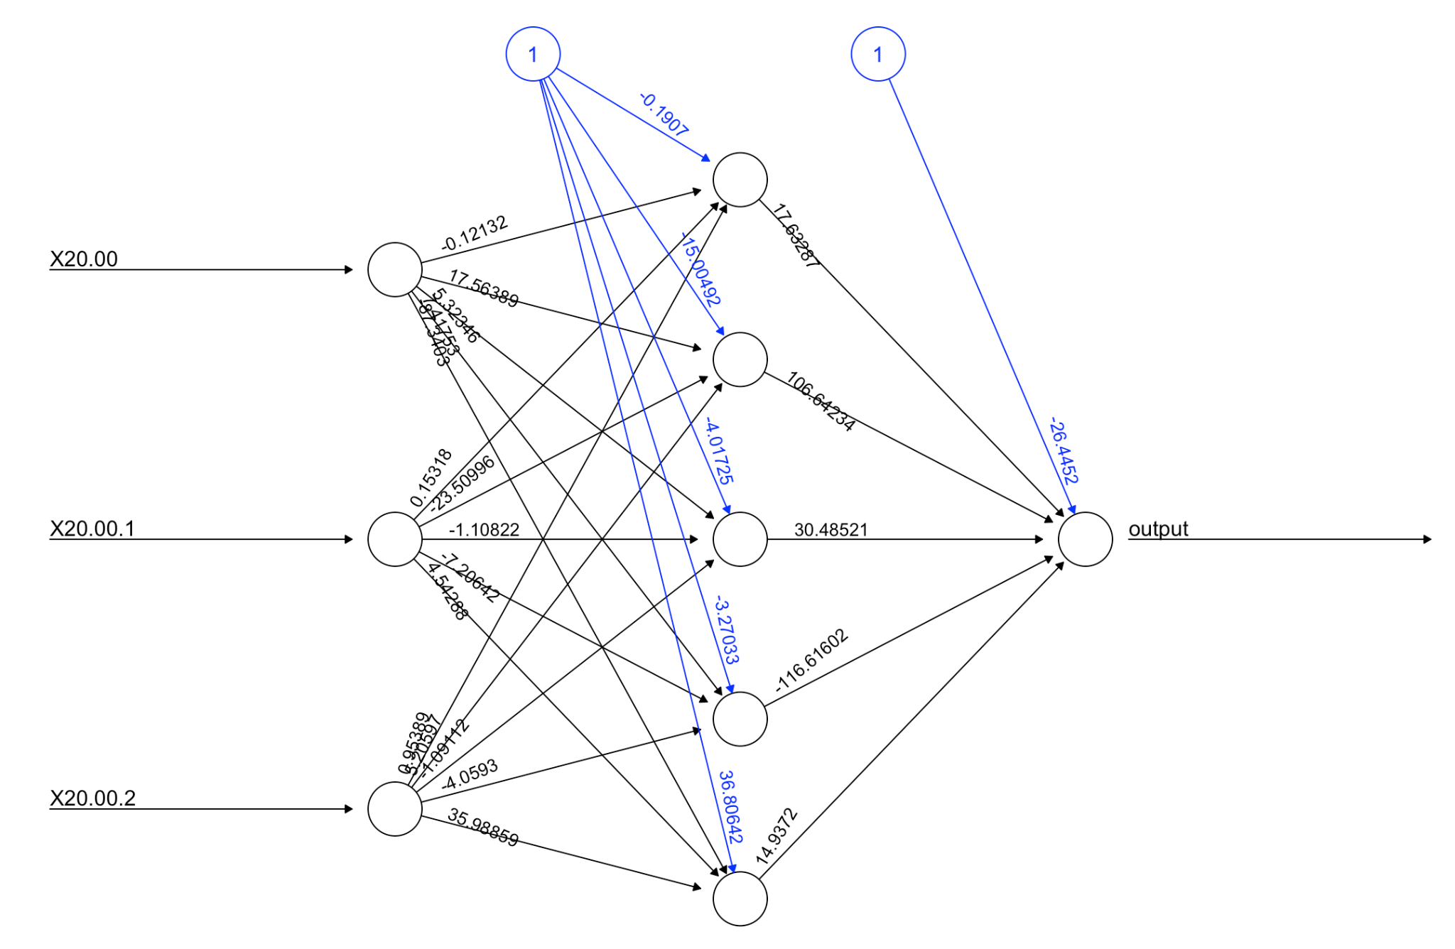

The MLP model is trained using the neuralnet. It is trained by using the output column as the prediction and all other data in the train_data dataset as past data parameters. The model finds the pattern of the data and trains itself according to the given hidden layer counts and activation function. And then predict the results accordingly.

test_pred <- compute(selected_mlp, test_data[, -ncol(test_data)])

At the moment, all data are scaled. To compare predicted values and expected values, the data points must be denormalized. In the denormalization process, scaled data will be converted back to their original values, or the predicted original values. Because the training process is finished, it is not necessary to keep the data in normalized form.

*# Backscale the predictions back to the original scale*

test_pred_rescaled <- test_pred$net.result * sd(output_data$output) + mean(output_data$output)

*# Backscale the output back to the original scale*

test_data_df <- as.data.frame(test_data)

test_output_rescaled <- test_data_df$output * sd(output_data$output) + mean(output_data$output)

After the de-normalized, the predicted result can be compared with the expected results. Below images show the comparison table in the left side, which represents the expected and predicted data in numerically and the expected vs predicted plot in right side, which represents the graph of expected and the predicted results.

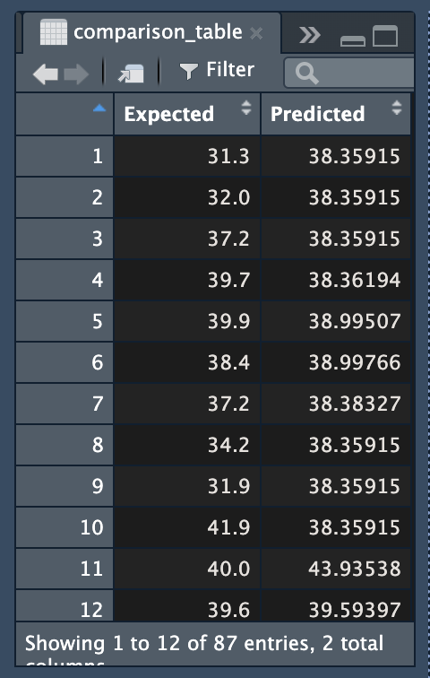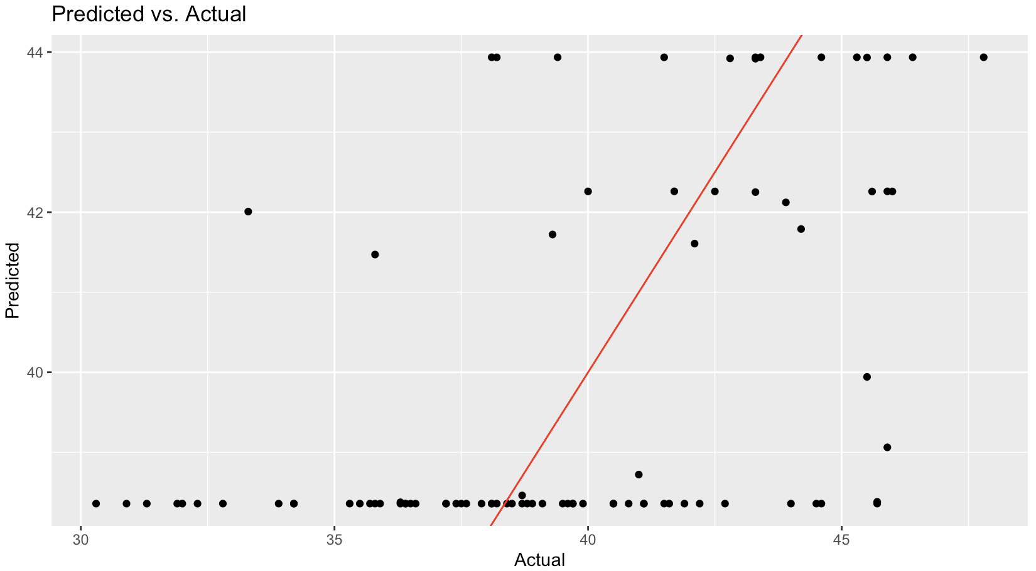

It is important to evaluate the performance of a model. To do this, RMSE, MAE, MAPE, and sMAPE are commonly used metrics. These metrics may help to get a better understanding of modelperformance.

mse <- mean((test_pred_rescaled - test_output_rescaled)^2)

rmse <- sqrt(mse)

mae <- mean(abs(test_pred_rescaled - test_output_rescaled))

mape <- mean(abs((test_output_rescaled - test_pred_rescaled)/test_output_rescaled)) * 100

smape <- mean(2 * abs(test_pred_rescaled - test_output_rescaled) / (abs(test_pred_rescaled) +

abs(test_output_rescaled))) * 100

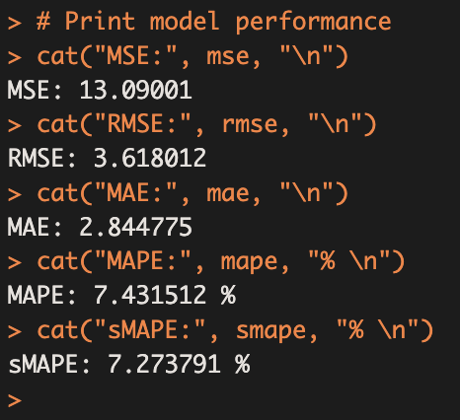

### 

### Standard Statistical Indices

It is important to identify eros and the accuracy performance in a machine learning model. So, There are several standard statistical indices used in machine learning to evaluate the model performance:

* Root mean squared error (RMSE): This is one of the most common error measurers. It's calculated by getting the root of the average of squared difference between the actual and predicted values. This Penalizes large errors more heavily than small errors ans sensitive to outliers. Low RMSE values represents the better peformance.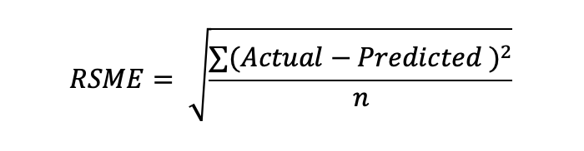
* Mean absolute error (MAE): This is another common measurement of error. This is calculated by getting the average value of the absolute difference between the actual and the predicted values. MAE is less sensitive to outliers than RMSE and also low MAE value represents the better peformance.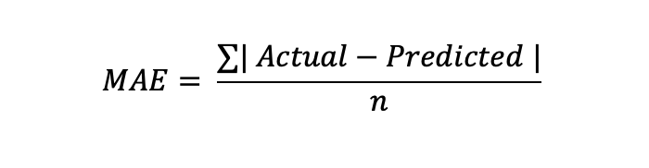
* Mean absolute percentage error (MAPE): MAPE is calculated by, taking the average of the absolute percentage differences between the predicted and actual values. MAPE is Easy to interpret as a percentage. Low MAPE value represents the better peformance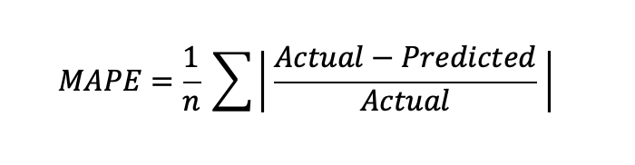
* Symmetric mean absolute percentage error (sMAPE): This is calculated by taking the average of the absolute percentage differences between the predicted values and the actual values, divided by the average of the absolute percentage differences between the actual values and the mean of the actual values. low sMAPE value represents the better peformance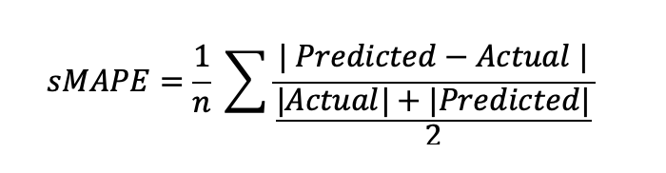

### 

### Performance Comparison

In this scenario, two activation functions (logistic and tanh) are being considered. Additionally, there are input variables of relatively small and slightly large sizes { 3: [t_3, t_2, t_1] and 7: [t_7, t_6, t_5, t_4, t_3, t_2, t_1]}. They also considered. The option of using one hidden layer (Small num and Big num) or two hidden layers (Small num and Big num) is also available.

In this case, all of these variables are will be compared with other groups of variables to get a better conclusion.

| MLP | Input Variables | Activation  Function | Input Layers | Hidden  Layers | RSME | MAE | MAPE | sMAPE |
| --- | --- | --- | --- | --- | --- | --- | --- | --- |
| MLP-01 | t_3, t_2, t_1 | logistic | 3 | 3 | 3.47 | 2.80 | 7.30 | 7.16 |
| MLP-02 | t_3, t_2, t_1 | logistic | 3 | 5 | 3.64 | 3.01 | 7.78 | 7.67 |
| MLP-03 | t_3, t_2, t_1 | logistic | 3 | 3,2 | 3.46 | 2.73 | 7.14 | 7.00 |
| MLP-04 | t_3, t_2, t_1 | logistic | 3 | 5,7 | 3.69 | 2.89 | 7.53 | 7.40 |
| MLP-05 | t_7, t_6, t_5, t_4, t_3, t_2, t_1 | logistic | 7 | 3 | 3.51 | 2.58 | 6.80 | 6.56 |
| MLP-06 | t_7, t_6, t_5, t_4, t_3, t_2, t_1 | logistic | 7 | 5 | 3.61 | 2.72 | 7.14 | 6.89 |
| MLP-07 | t_7, t_6, t_5, t_4, t_3, t_2, t_1 | logistic | 7 | 3,2 | 3.51 | 2.59 | 6.82 | 6.58 |
| MLP-08 | t_7, t_6, t_5, t_4, t_3, t_2, t_1 | logistic | 7 | 5,7 | 3.87 | 2.89 | 7.61 | 7.31 |
| MLP-09 | t_3, t_2, t_1 | tanh | 3 | 3 | 3.67 | 3.00 | 7.71 | 7.72 |
| MLP-10 | t_3, t_2, t_1 | tanh | 3 | 5 | 4.17 | 3.26 | 8.36 | 8.40 |
| MLP-11 | t_3, t_2, t_1 | tanh | 3 | 3,2 | 3.87 | 3.01 | 7.75 | 7.74 |
| MLP-12 | t_3, t_2, t_1 | tanh | 3 | 5,7 | err |  |  |  |
| MLP-13 | t_7, t_6, t_5, t_4, t_3, t_2, t_1 | tanh | 7 | 3 | 3.70 | 2.90 | 7.46 | 7.40 |
| MLP-14 | t_7, t_6, t_5, t_4, t_3, t_2, t_1 | tanh | 7 | 5 | 4.17 | 3.26 | 8.36 | 8.40 |
| MLP-15 | t_7, t_6, t_5, t_4, t_3, t_2, t_1 | tanh | 7 | 3,2 | 3.89 | 2.93 | 7.45 | 7.55 |
| MLP-16 | t_7, t_6, t_5, t_4, t_3, t_2, t_1 | tanh | 7 | 5,7 | err |  |  |  |

### Efficieny of Hidden Layer Networks

To check the efficiency of the one-hidden layer and two-hidden layer networks, it is required to calculate the total number of weight parameters per network. The number of weight parameters is equal to the number of connections between neurons in the network.

For the one-hidden layer networks, the total number of weight parameters is follows:

* MLP-01: (3 inputN * 3 hiddenN) + (3 hiddenN * 1 outputN) = 12
* MLP-02: (3 inputN * 5 hiddenN) + (5 hiddenN * 1 outputN) = 20
* MLP-05: (7 inputN * 3 hiddenN) + (3 hiddenN * 1 outputN) = 24
* MLP-06: (7 inputN * 5 hiddenN) + (5 hiddenN * 1 outputN) = 40
* MLP-09: (3 inputN * 3 hiddenN) + (3 hiddenN * 1 outputN) = 12
* MLP-10: (3 inputN * 5 hiddenN) + (5 hiddenN * 1 outputN) = 20
* MLP-13: (7 inputN * 3 hiddenN) + (3 hiddenN * 1 outputN) = 24
* MLP-14: (7 inputN * 5 hiddenN) + (5 hiddenN * 1 outputN) = 40

For the two-hidden layer networks, the total number of weight parameters is calculated as follows:

* MLP-03: (3 inputN * 3 hiddenN) + (3 hiddenN * 2 hiddenN) + (2 hiddenN * 1 outputN) = 17
* MLP-04: (3 inputN * 5 hiddenN) + (5 hiddenN * 7 hiddenN) + (7 hiddenN * 1 outputN) = 59
* MLP-07: (7 inputN * 3 hiddenN) + (3 hiddenN * 2 hiddenN) + (2 hiddenN * 1 outputN) = 23
* MLP-08: (7 inputN * 5 hiddenN) + (5 hiddenN * 7 hiddenN) + (7 hiddenN * 1 outputN) = 83
* MLP-11: (3 inputN * 3 hiddenN) + (3 hiddenN * 2 hiddenN) + (2 hiddenN * 1 outputN) = 17
* MLP-12: (3 inputN * 5 hiddenN) + (5 hiddenN * 7 hiddenN) + (7 hiddenN * 1 outputN) = 59
* MLP-15: (7 inputN * 3 hiddenN) + (3 hiddenN * 2 hiddenN) + (2 hiddenN * 1 outputN) = 23
* MLP-16: (7 inputN * 5 hiddenN) + (5 hiddenN * 7 hiddenN) + (7 hiddenN * 1 outputN) = 83

Based on the above calculation, One-hidden layer neurall network have fewer weight parameters than the two-layers neural networks. This means that the one-hidden layer NN are more efficient than the two-hidden layer NN.

However, the two-hidden layer networks are more accurate than the one-hidden layer networks. But according to the comparison table, the difference between RSME, MAE, MAPE and sMAPE are relatively small. So, it is not considerable and can be assume that the both one-hidden layer and two-hidden layer accuracy are same. And also, compared to real world scenarios using NN, this task is comparably small.

So, in this case it is prefer to use a One-Hidden layer neural network.

## 2nd Subtask (NARX Approach)

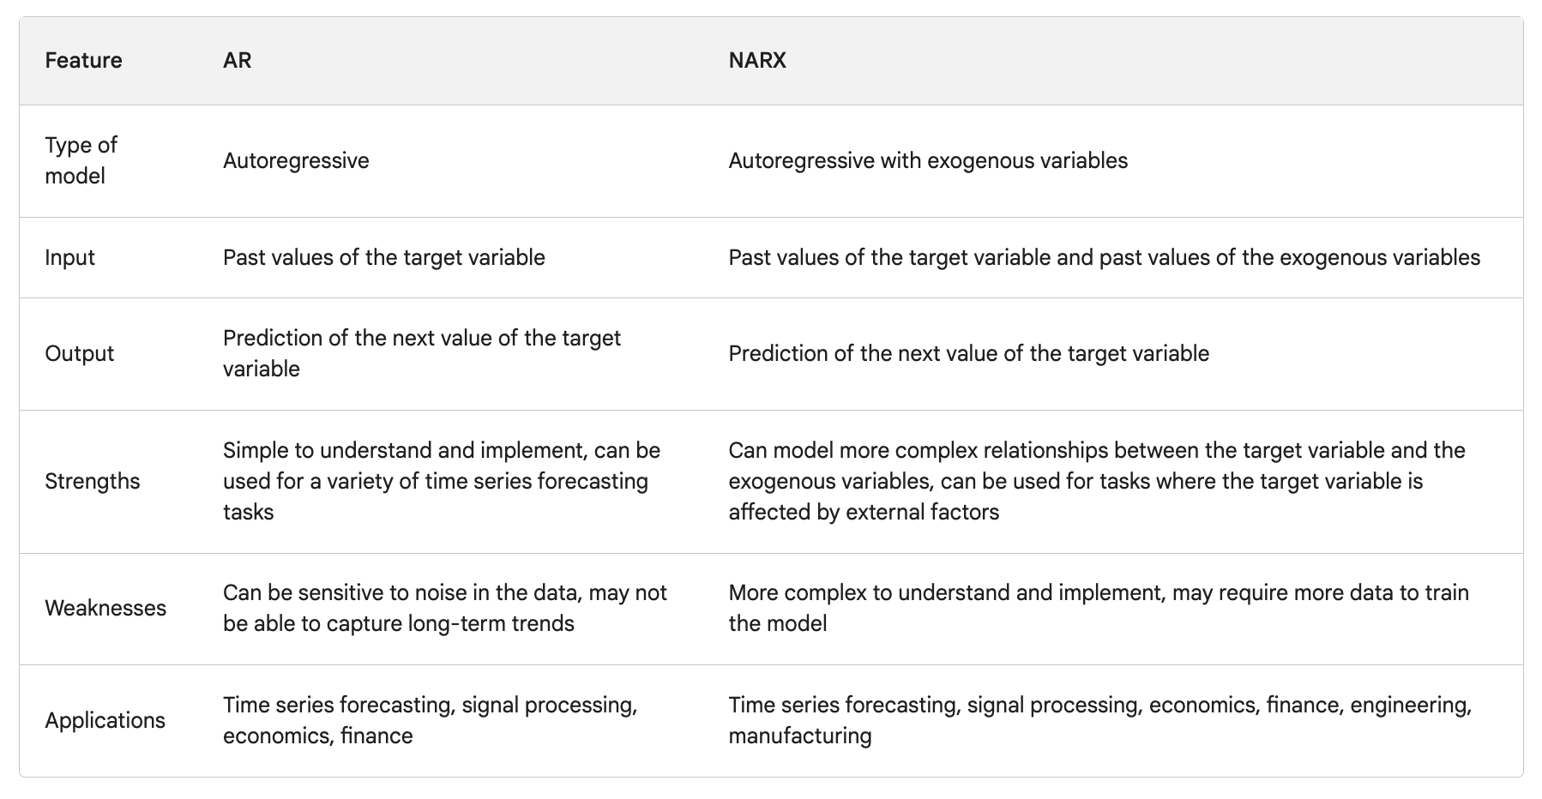

Yes, there is an order to make the matrix to pass into the prediction. The order is as follows:

1. The past value of the target variable at time `t-1`

2. The past value of the target variable at time `t-2`

3. ...

4. The past value of the target variable at time `t-p`

5. The past value of the exogenous variable at time `t-1`

6. The past value of the exogenous variable at time `t-2`

7. ...

8. The past value of the exogenous variable at time `t-q`

Where:

* `p` is the number of past values of the target variable to use

* `q` is the number of past values of the exogenous variables to use

For example, if you are using a NARX model with `p=3` and `q=2`, then the order of the matrix would be as follows:

1. The past value of the target variable at time `t-1`

2. The past value of the target variable at time `t-2`

3. The past value of the target variable at time `t-3`

4. The past value of the exogenous variable at time `t-1`

5. The past value of the exogenous variable at time `t-2`

I hope this explanation is helpful. Please let me know if you have any other questions.

The order of the input variables is important because it determines the sequence of the time series data that the NARX model will use to make predictions. In a time series problem, the order of the data points matters because the current value of the time series is often dependent on the past values. Therefore, the order of the input variables should reflect the chronological order of the time series data.

In the case of a NARX model, the input variables are the past values of the time series, which are used to predict the future values. The order of the input variables should be from the most recent to the oldest data, so that the model can learn the patterns and dependencies in the time series data in the correct order. If the order of the input variables is incorrect, the model may not be able to learn the correct patterns and dependencies, which can lead to poor predictions.

In summary, the order of the input variables is important in a NARX model because it determines the sequence of the time series data that the model will use to make predictions, and the order should reflect the chronological order of the time series data.

In the matrix, the oldest data should be in the rightmost column. This is because the input matrix for a NARX model should have the most recent data in the first column and the oldest data in the last column.

The reason for this is that the NARX model uses the past values of the time series to predict the future values. The most recent data is the most relevant for predicting the next value, while the oldest data is the least relevant. Therefore, the model should be trained on the most recent data first, and then gradually incorporate the older data.

By putting the oldest data in the rightmost column, the input matrix follows the chronological order of the time series data, with the most recent data on the left and the oldest data on the right. This ensures that the NARX model learns the patterns and dependencies in the time series data in the correct order, which can lead to better predictions.

The oldest data should be on the left side of the matrix. This is because the NARX model uses the past values of the target variable and the exogenous variables to predict the next value of the target variable. The older the data, the further back in time it is, and therefore the more likely it is to be relevant to the prediction.

For example, if you are using a NARX model with p=3 and q=2, then the first three columns of the matrix would contain the past values of the target variable, and the last two columns would contain the past values of the exogenous variables. The oldest data would be in the first column, and the newest data would be in the last column.

# Appendix

## Clustering Code

## PCA Code

## AR Model Code

## NARX Model Code

# References

NBclust, Elbow, Gap statistics and silhouette

* <https://www.datanovia.com/en/lessons/determining-the-optimal-number-of-clusters-3-must-know-methods/>
* <https://journal.binus.ac.id/index.php/comtech/article/view/7270>

Zhu, J., Yang, Z., Mourshed, M., Guo, Y., Zhou, Y., Chang, Y., Wei, Y., & Feng, S. (2019, July 13). Electric Vehicle Charging Load Forecasting: A Comparative Study of Deep Learning Approaches. *Energies*, *12*(14), 2692. https://doi.org/10.3390/en12142692

Hyndman, R.J., & Athanasopoulos, G. (2018) Forecasting: principles and practice, 2nd edition, OTexts: Melbourne, Australia. OTexts.com/fpp2. Accessed on <current date>.